e House of Pain

Lessons

By Walt Webb

May 2001

[www.aloa.org](http://www.aloa.org)

C»HT I O 'KMA«5TFO«5 »OBR

Bypassing the GM MATS ILCO 54 Series Safe Depnsit Lacks Institutional - Yesterday, Today and Tomorrow CyberLock's 1C Core And More

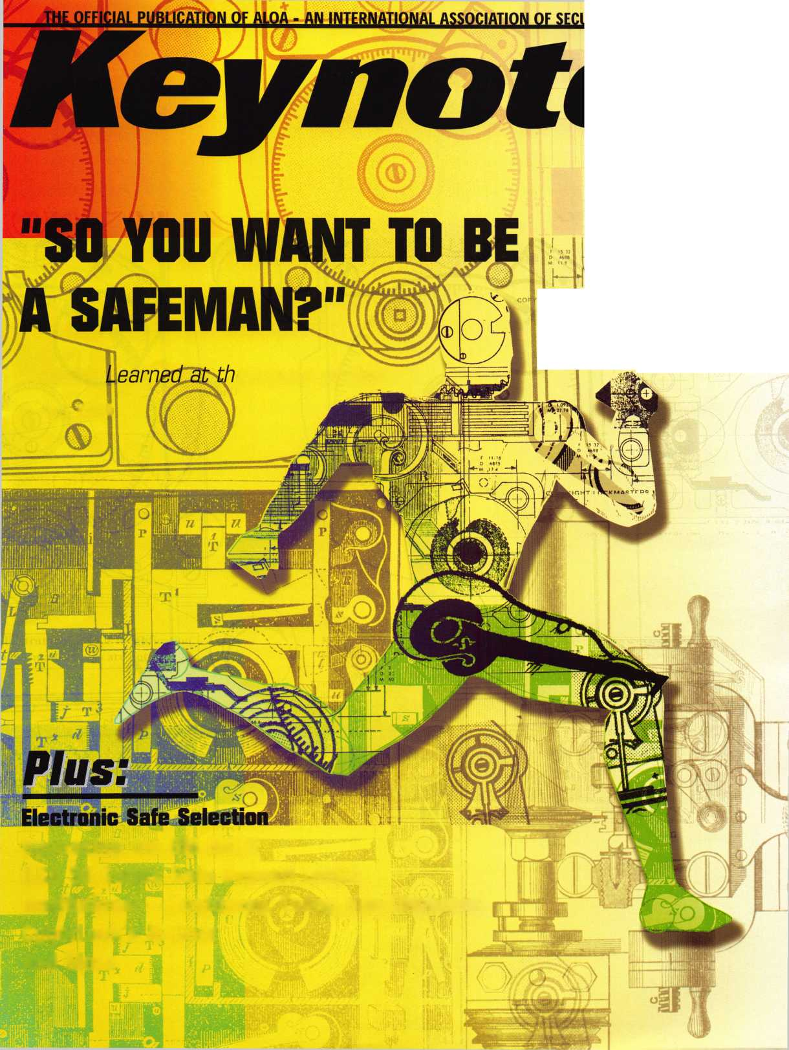

year one,

witn

do you know what to expect

when tomorrow arrives?

—1

ess the unexpected july 15-22

at baltimore convention center.

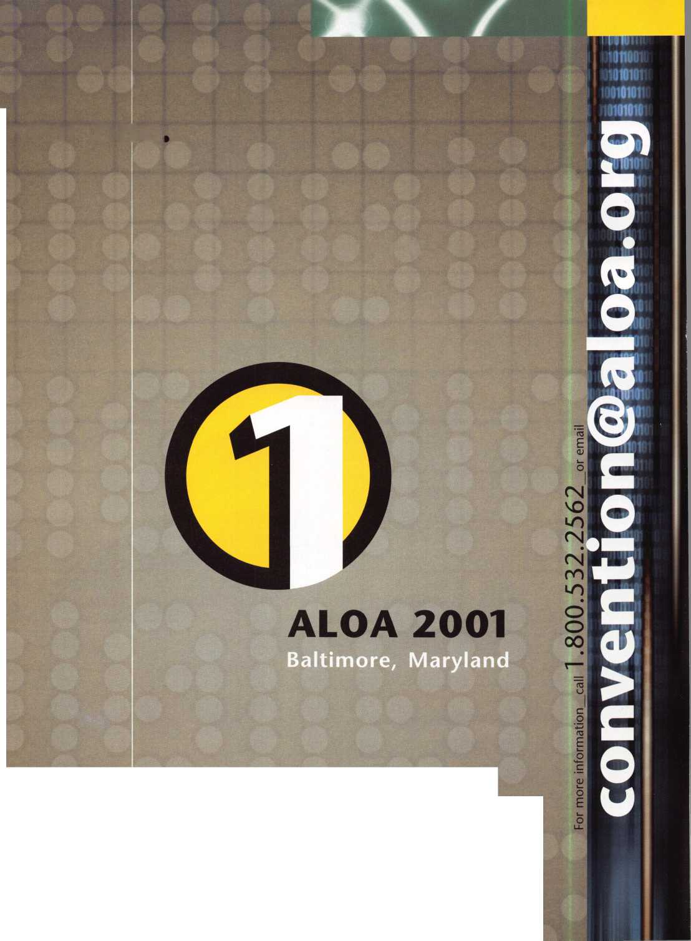

You'll never be caught with the wrong bolt.

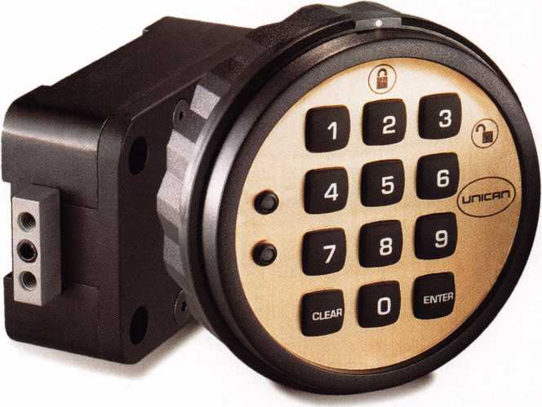

All the features you would expect,

plus Convert-A-Bolt™ technology

to save you time and reduce your inventory.

It's patented inside and out. It might look like all the others, but the  
electro-mechanical SAFELOCK 515 is exceptionally engineered. Its patented  
design includes Convert-A-Bolt™ technology for field-selectable

deadbolt / springbolt. It's packed with features. UL listed Type 1,  
the SAFELOCK 515 features include four security levels and  
programmable dual custody, time delay, open window, and lockout.  
And it costs less. The SAFELOCK 515 is fully programmable from the  
keypad, requiring no distributor programming fees, expensive modules, or  
hand-held programmers. With more security for less investment,

the SAFELOCK 515 is the ideal choice.

Call 800-849-8324  
[www.ilcounican.com](http://www.ilcounican.com)

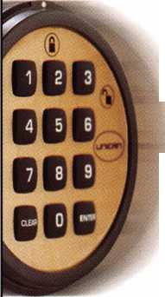

May 2001

Volume 47, Issue 5

CO

iu

oc

D

I-

<

III

Li.

2 | ***Keynotes***

4

**President’s Journey**

By John Greenan, CML, CPS

14

Cover Feature: So You Want to Be a Safeman?

**Lessons Learned at the House of Pain**

The whole job took me about two years. I spent hundreds of dollars on books, classes, and assorted tools and drill bits. It probably a good thing I am a firefighter full time; I may need a little more experience before I hang out my "SAFE-MAN" shingle.

By Walt Webb

18

**Electronic Safe Lock Selection**

Probably the best approach to electronic safe locks today is learning about those models that you are most likely to encounter in your day- to-day work. These are the locks you see on show room safes, in the literature from the safe manufacturers as options on their products and a few additional locks worth considering as replacements onto exist­ing safes. Let's take a look.

By Charles Stephenson, CPS

22

Automotive:

**Bypassing the Anti-Theft Ring GIVTs MATS Column**

If you do automotive work, and have not had the opportunity to expe­rience GM's MATS column, you will eventually. Of course, the first time you encounter this column, the vehicle will be parked with the front wheels against a parking lot barrier or against a curb. No prob­lem, with this technique, it won't matter.

By Bob Arhtur, CRL

26

Institutional Locksmithing:

**Past Present and Future**

A locksmith's job is based largely in customer service. In institutional work, the "customers" differ greatly from traditional shop customers. Here's how one locksmith took care of certain institutional situations that called for lots of locksmith know-how, and lots of diplomatic protocol.

By C.D. Lipscomb, CML, CPS

30

Traditional Locksmithing

**llco 54 Series Safe Deposit Locks**

The llco 54 Series safe deposit lock is a double nose lock, with separate key holes for each key. It is double changeable and both the guard and renter keys can be changed. Here's how to service it.

By Sal Dulcamara, CML

34

Access Control:

**Videx announces its new series of 1C**

Videx recently announced that CyberLock technology has been incor­porated into the interchangeable core cylinder and T-handle cylinder. The interchangeable core and T-handle cylinders join what is an extensive line-up of intelligent lock cylinders in the CyberLock fami­ly. Check out this helpful overview.

***May 2001***

**DEPARTMENTS**

2

Contents

4

President's Journey

6

Upcoming Events

8

Core

12

Applicants

38

Legislative Update

40

Classifieds

42

Associate Member Listing

44

Back Page

VISIT OUR WEB SITE AT:

[www.aloa.org](http://www.aloa.org)



|  |  |  |  |
| --- | --- | --- | --- |
| Editor | Jim DeSimone [editor@aloa.org](mailto:editor@aloa.org) | Executive Director | Charles W. Gibson, Jr., CAE [charlie@aloa.org](mailto:charlie@aloa.org) |
| Technical Editor | David Lowell, CML, CMST |  |
|  | [david@aloa.org](mailto:david@aloa.org) | Convention & Meetings Manager | Kelly Carr, CMP [kelly@aloa.org](mailto:kelly@aloa.org) |
| Editorial Advisor | John D. Cannon, CML j [dcannon@worldnet.att](mailto:dcannon@worldnet.att). net | Convention & Meetings Assistant |
| Karen Lyons, [Karen@aloa.org](mailto:Karen@aloa.org) |
| Art Director | Lindsay Magers |  |
|  | [lindsay@aloa.org](mailto:lindsay@aloa.org) | PRP/Education Manager | David Lowell, |
|  |  | CML, CMST |
| Advertising Sales | Susan Haverkamp |  | [david@aloa.org](mailto:david@aloa.org) |
|  | 121 Davis Street |  |
|  | Nacogdoches, Texas 75961 | Operations/Membership Manager | Mary May |
|  | Phone: (936) 569-7172 VoiceMail: (208) 248-8893 | [mary@aloa.org](mailto:mary@aloa.org) |
|  |
|  | e-mail: [adsales@aloa.org](mailto:adsales@aloa.org) | Director of Information Technology | Randy McChristian [randy@aloa.org](mailto:randy@aloa.org) |
| Contributors | Jerome Andrews, CML |  |
|  | Paul Chandler, CRL  Claire Cohen, CML | Government Affairs Manager/ Chapters & Regional Associations Liaison | Tim McMullen [tim@aloa.org](mailto:tim@aloa.org) |
|  | Brian Costley, CML, CMST |
|  | Ray D'Adamo, CML  Sal Dulcamaro, CML | Comptroller | Kathy J. Romo |
|  | Billy Edwards, CML | Network Specialist | Greg Jackson |
|  | Dan Graffeo, CRL,CMST | Membership Coordinator | Shelly Jett |
|  | A.J. Hoffman, CML |
|  | Jeff Nunberg, CML, CMST | PRP/Education Coordinator | Ashley Manson |
|  | Mikey Oehlert, CPL, CPS  Randy Simpson, CML | Accounting Coordinator | Kathy Stokes |
|  | Robert Stafford, CML | Mail Room Coordinator | Humberto Cerda |
|  | Dave Thielen, CML  Greg Perry, CML,CPS | Receptionist | Alin Valdez |
|  | Tom Seroogy |  |  |
|  | Charles Stephenson, CPS |  |  |
|  | Dennis Watanabe, CML, CMST |  |  |

Additional contact information for the ALOA Board and most Keynotes authors is available through “Locksmith Search’" on the ALOA Web site- [www.aioa.org](http://www.aioa.org) or by contacting the ALOA office at 3003 Live Oak Street; Dallas, TX 75204; (800)532-2562;

FAX (214)827-1810; e-mail [aloa@aloa.org](mailto:aloa@aloa.org).



President

John J. Greenan, CML, CPS (773) 486-2030 [fsl.john@mindspring.com](mailto:fsl.john@mindspring.com)

Secretary

John D. Cannon. CML (703) 960-6413 [jdcannon@worldnet.att.net](mailto:jdcannon@worldnet.att.net) Directors, Northeast John C. Magee, III (856) 845-3434 Peter Sarailian, CRL (201) 947-6291 [psarailian@yahoo.com](mailto:psarailian@yahoo.com) William L. Young, CML (610) 647-5042 Directors, Southeast Thomas W. Tate (850) 476-4211 Donald E. Rule. CML

1. 324-2658 [rulecml@ebicom.net](mailto:rulecml@ebicom.net) Directors, North Central Mark E. Blum, CML, CPS (517) 482-5809 [mblum@arq.net](mailto:mblum@arq.net)

Tom Ripp, CRL (608) 262-3831 Director, South Central Randy L. Simpson, CML (713) 780-7026 Directors, Southwest Gordon R. Racine, CML (719) 384-4707 [aloaswdir@excite.com](mailto:aloaswdir@excite.com) John A. Ilk, CRL

1. 420-2174 [getreil@yahoo.com](mailto:getreil@yahoo.com) Director, Northwest Scott L. Henke, CRL, CPS (907) 248-3785 [action@alaska.net](mailto:action@alaska.net)

Director, Associate Members

David F. Matthies

(727) 541-5536

[dmatthies@southernlock.com](mailto:dmatthies@southernlock.com)

Trustees

Dallas Brooks

(334) 826-8990

David M. Lowell, CML, CMST

(800) 532-2562

Breck H. Camp, CML

(770) 455-6244

Edwin Toepfer, RL

(416) 225-5589

Mission Statement: The Associated Locksmiths of America, Inc. is dedicated to enhancing the professionalism, education and ethics among locksmiths and those in related sectors of the physical security industry. With approximately 10,000 members in the United States, Canada and the freeworld, ALOA is poised to help members obtain the knowledge, the strength, and the confidence to perform their role in the physical security field with pride and dignity. But it is only through active involvement and participation that ALOA can fully achieve its potential-and can help members to achieve theirs.

Policies: Keynoted* is the official publication of the Associated Locksmiths of America, Inc. (ALOA). Keynoted acts as a moderator without approving, disapproving, or guaranteeing the validity or accuracy of any data, claim, or opinion appearing under a byline or obtained or quoted from an acknowledged source. The opinions expressed by the authors do not necessarily reflect the official views of ALOA. Also, appearance of advertisements and new products or service information does not constitute an endorsement of products or services featured by the Association. The Association does not accept responsibility for the inaccuracy of any data, claim, or opinion appearing in this publication, due to typographical errors on the part of the authors, Association staff or its agents. Editor’s Note: This publication is designed to provide accurate and authoritative information in regard to the subject matter covered. It is provided and disseminated with the understanding that the publisher is not engaged in rendering legal or other professional services. If legal advice and other expert assistance is required, the services of a competent professional should be sought.

Authors’ Payment: Payment for eligible submissions to Keynotes will be based on the following criteria: topic, time spent and past contributions. Authors who regularly submit to Keynotes are generally paid a higher rate. The latter is especially true of authors who write to fit specific editorial needs and submit said copy by Keynotes deadlines. As a general guideline: Average payment for a 750 word, business or ‘light’ technical article would be $200. Payment for a 1500 word article involving significantly higher time and research efforts would be $400.

Payment will not be offered for articles submitted by ALOA employees or members of the ALOA Board of Directors (unless material is of a technical nature), nor for articles submitted by a company that promote that company’s products or services. ALOA reserves the right not to pay for articles submitted by an individuals) that promote a particular company’s products or services.

Disclaimer: The Associated Locksmiths of America, Inc., (ALOA), reserves the right to refuse any article for any reason. Additionally, ALOA reserves the right to edit, amend or modify any article submitted for publication in order to preserve technical accuracy, clarity, fairness or grammatical correctness. ALOA will make the best efforts to notify the author of any changes. The extent of ALOA’s liability for any article or information contained therein will be a notice of correction or retraction in the next possible issue.

Keynoted (ISSN 0277 0792) is published monthly except for the combined June/July issue by The Associated Locksmiths of America, Inc., 3003 Live Oak St., Dallas, TX 75204-6186. Telephone: (214) 827-1701; FAX (214) 827-1810; e-mail [aloa@aloa.org](mailto:aloa@aloa.org). Subscription rates for members-$15.00 per year. Second class postage paid at Dallas, Texas. POSTMASTER: Send address changes to: Keynotes, 3003 Live Oak St., Dallas, TX 75204-6186. © Copyright 1999, All rights reserved. No part of the contents may be reproduced or reprinted in any form without prior written permission of the publisher.

Past Presidents

1997-1999 Dallas C. Brooks 1995-1997 David Lowell, CML, CMST 1993-1995 Breck Camp, CML 1991-1993 Henry Printz, CML 1989-1991 Evelyn Wersonick, CML, CPS 1987-1989 Leonard Passarello, CPL 1985-1987 Joe Jackman, CML 1983-1985 Stanley Haney, CPL 1981-1983 Louis LaGreco, CPL 1979-1981 John Kerr, RL 1977-1979 Clifford Cox, CML 1974-1977 Charles Hetherington 1972-1974 Gene Laughridge 1970-1972 William Dutcher, RL 1968-1970 Constant Maffey, RL 1966-1968 Harold Edelstein, RL 1964-1966 William Meacham 1962-1964 Robert Rackliffe, CPL 1960-1962 Edwin Toepfer, RL 1956-1960 Ernest Johannesen

***May 2001***

***Keynotes*** |3

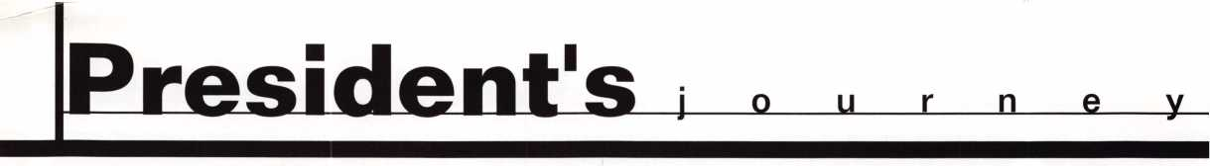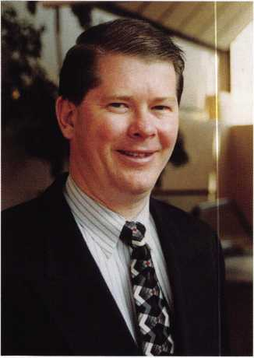

You may have noticed that on your ALOA dues billing, we asked you a few ques­tions about your type of business, work environment, job function, company’s annual gross sales, and company’s annual resale hardware sales. The reason we asked you those questions, was to prove quantitatively that ALOA members represent a very healthy and profitable segment of the security industry.

With already over half of our membership responding to the survey, what we have is a better picture of what we already knew: ALOA members are moving their busi­nesses into the 21st century in terms of hardware sales and service.

A large majority of ALOA’s members are doing some type of Commercial lock- smithing (77%). This segment of the industry is less affected by inflation or reces­sion. A significant amount of ALOA’s members are doing Electronic locksmithing and Safes & Vaults (39%). This amounts to more high-end sales and service oppor­tunities as well as movement toward the future of our industry. Only about a third (30.6%) of our members do some type of Automotive locksmithing.

More than half of ALOA’s members (54.2%) work from a storefront and have mobile service. This means they have showrooms for displaying security hardware items. An overwhelming majority (73.1%) of ALOA’s members are owners/managers. This translates to decision makers in purchasing.

The total annual estimated gross sales of ALOA’s membership is $1,024,943,000 (yes, that is over 1 billion). The total annual estimated retail hardware sales of ALOA’s membership is $681,359,000 More importantly, this translates to $408,815,400 in wholesale buying power of ALOA’s combined membership, based on an industry average of 40% off the retail-selling price.

There is still one locksmithing segment, that ALOA needs to address. We currently are not attracting a large number of institutional locksmiths based on a 14.1% mem­bership. However, we are addressing this situation, with monthly coverage of institu­tional locksmithing in Keynotes magazine, and attendance at the ALOA Board meet­ings by the President of the Institutional Locksmiths Association.

For all of you who did respond, thank you. What these numbers do show is a thriv­ing ALOA - a promising future for security professionals. More importantly, it means our members represent tremendous purchasing power.

Keep up the good work!

John J. Greenan, CML, CPS

***May 2007***

41 ***Keynotes***



*Visit our Website on  
www. stamcctv. com*

**THE COMPLETE**

**CCTV PROGRAM ON CD-ROM  
FOR STAFF TRAINING AND**

**PRODUCTIVITY ENHANCEMENT**

STAM **Insight** has been  
developed to enhance CCTV

skills and productivity with  
many different uses.

O Productivity

System Drawing  
Estimation  
CCTV Training  
CCTV Reference  
Sales/Demo  
System Design  
Staff Evaluation

**NFOMATE WORKMATE ULTIMATE**

Sold in Over 50 Countries



Distributed by:

3003 Live Oak Street  
Dallas,Texas 75204

COPYRIGHT © 1996 Security Training and Marketing Pty Ltd.  
All rights reserved ACN 057 006 541

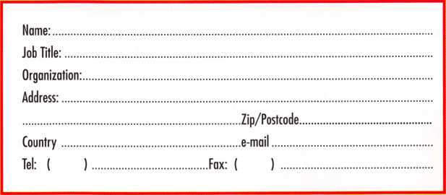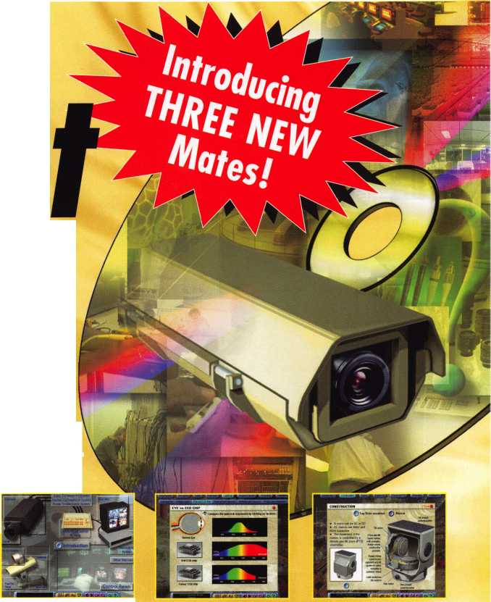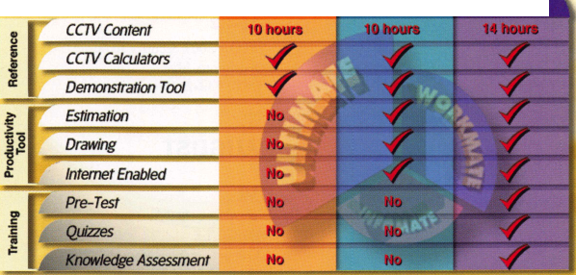

**2001**

**MAY**

8

5-6

Automotive Transponder Hands-on "Chamblee, GA" Georgia Chapter of ALOA "Stephen Gebbia, CML"

(770)-45 5-6244

5

^SAFETECH 2001 St. Louis, MO (214)827-7233 IDET 2001

6th International Exhibition of Defense and Security Technology

5

Georgia Chapter of ALOA Chamblee, GA

Contact: Stephen Gebbia, CML 770/455-6244

f/' ALOA PRP Sitting Dallas, TX

Contact: Ashley Manson (214)827-1701 (214) 827-1810 fax

14-17

New Mexico Locksmith Association NMLA Convention 6 VARIOUS ACE CLASSES Ruidoso, NM Contact: Steve Smith 505/281-6777

24

0* ALOA PRP Sitting Sacramento, CA Clark Security Products Contact: Joan Emrick (619) 718-7308

1. 11

Fairgrounds Brno, Czech Republic Contact: Messe Dusseldorf 312/781-5180

e-mail: [info@mdna.com](mailto:info@mdna.com) <<mailto:info@mdna.com>

1. 13

f/ ALOA PRP Sitting

IDN 2001 Trade Show & Security Conference

Ypsilanti, MI

Contact: Fred Strasberger

(800)521-0955 or

Bonnie Weston

(734)591-1150

**JULY**

13

ft ALOA PRP Sitting Dallas, TX

Contact: Ashley Manson (214)827-1701 (214) 827-1810 fax

15-22

ALOA 2001 Security Expo Baltimore, MD (800)532-2562

11

f/ ALOA PRP Sitting Dallas, TX

Contact: Ashley Manson (214)827-1701 (214) 827-1810 fax

19

Grand Canyon Chapter of ALOA Introduction to Access Control Phoenix, AZ Contact: John Ilk, CRL 602/420-2174

**JUNE**

3

North Jersey Master Locksmith Association 7 th Annual Flea Market and Swap Meet Quality Inn Lyndhurst, New Jersey (201) 944-7547

**AUGUST**

10

ft ALOA PRP Sitting Dallas, TX

Contact: Ashley Manson (214)827-1701 (214) 827-1810 fax

**SEPTEMBER**

14

ft ALOA PRP Sitting Dallas, TX

Contact: Ashley Manson 800/532-ALOA (2562) (214) 827-1810 fax

27-28

MINK Convention Contact: Elmer Howard (402)330-8701

**OCTOBER**

12

ft ALOA PRP Sitting Dallas, TX

Contact: Ashley Manson (214)827-1701 (214) 827-1810 fax

1. 21

Tri Regional Locksmith Conference Portland, OR

Pacific Locksmith Association Contact: Stan Hauer (503)325-7334 Email [hauer@pacifier.com](mailto:hauer@pacifier.com) Contact: Ken Mead (503)873-6932

1. 20

Combination Lock Manipulation (2 days)

Auto Loci Servicing (2 days)

Portland, OR

Tri-Regional Show Karl Kretsch (541)926-3525

Pacific Locksmith Association

Contact: Stan Hauer

(503)325-7334

Email [hauer@pacifier.com](mailto:hauer@pacifier.com)

Contact: Ken Mead

(503)873-6932

Indicates ALOA ACE Class Indicates PRP Sitting

***May 2001***

Keynotes

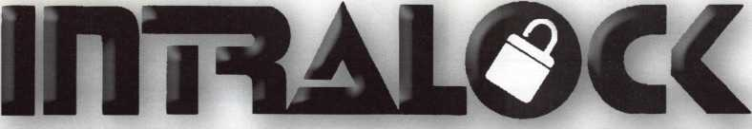

TOOLS LIMITED

**uiwui.intralocktools.com**

new

affordable

price!

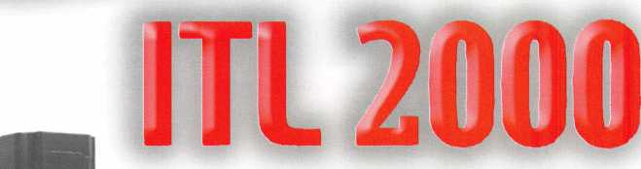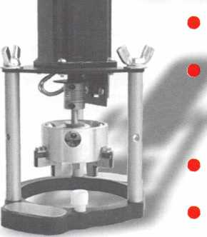

Super strong rare earth magnets  
Dial gripper with reversible shaped  
jaws to grip most dials  
Easy to assemble mounting jig  
Self contained - no computer required

Phone: (888) 264-6627 IPta^ ▲ | 2639-B Progressive Ulay

(604) 852-8904 || I I nAL\/%V Abbotsford, B.C.

USA: (562) 699-0060 **TOOLS LIMITED** U2T6H8

**Serving industry with superior products since 1985.**

May 2001

Keynotes

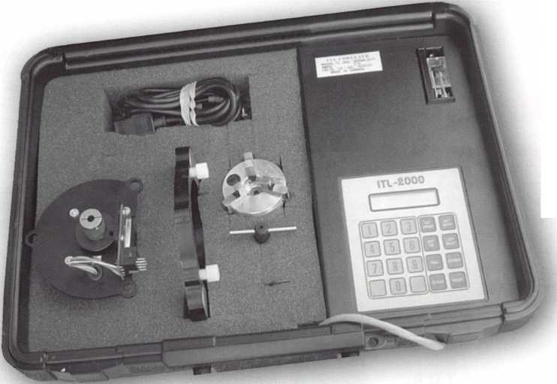

CORE

**Meet the Candidates**

Several ALOA Board seats are open and will be voted on by proxy in the next couple of weeks. We wanted to take  
this opportunity to introduce you to the candidates for these positions, and to remind you that your official ballots  
(mailed separately) are due by June 6, 2001. Don't pass up your chance to vote!

**For the Office of President**

Randy L. Simpson, CML

Randy began locksmithing in 1973 and became an ALOA  
member in 1985. Randy served on the Security Professional  
Council from 1993-1995. Beginning in 1995 Randy served as  
director of ALOA's board, chair of Public Relations and a  
member of the Bylaws and Legislation committees as well as  
contributing articles to Keynotes. He currently is still serving as  
South Central Region Director. As owner operator of Baker's

Safe and Lock Co., Inc. located in Houston, Texas, Randy manages 25 employ-  
ees who perform skilled integrated security service for major corporate  
accounts, from mechanical hardware to integrated electronic access systems.  
Interest and a desire to be evolved in current technology is important to Randy.

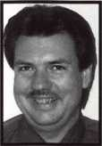

Tom Ripp

Tom Ripp has been a locksmith since high school in Waunakee,  
Wisconsin. Tom worked at Wauna-Key Safe & Lock where he later  
acquired its commercial trade name. He is currently a locksmith-  
journey at the University of Wisconsin-Madison. Tom is serving  
his first term as North Central Director. "All of the candidates are  
good friends of mine, each with different life experience's and  
they all have something to bring to your A.L.O.A. board. I would

like to see improvements in the membership directory - .A.L.O.A. members list-  
ed by company name & what they specialize in. I would also like to see more  
manufactures & distributors listed with product name. With an improved direc-  
tory, the public could go to you for that unusual or hard to find brand. We should  
offer the public more service than non-member's."

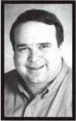

**For the Office of Director**

**North Central Region**

Robert M. Dennee

Robert M. Dennee has filed nomination papers for the posi-  
tion of ALOA Board of Directors - North Central Region. Bob  
has owned and operated Ace Lock and Security - Marshfield,  
Wisconsin, for the past 20-plus years and is a member of  
ALOA in two different terms for more than 12 years, Save and  
Vault Technicians Association since 1994 and International  
Association of Investigative Locksmiths since 1999. Also in

the state of Wisconsin, there are two ALOA chapters, and since being geo-  
graphically in the middle, Bob has been active in both since their inception. The  
Fox Valley Chapter of ALOA since 1992 [board of directors), the Indianhead  
Chapter since 1994 [chapter chairman for two years). Some of the challenges  
before us as "professional security technicians" is to stay educated with the  
changes in technology, continue to market our services not only locally but to  
national service providers (NSP) and recognize that our competition is not  
those in our own camp, but larger associations that provide alarm and elec-  
tronic security services. My position, if elected, is to further promote ALOA in  
this new millennium at the various trade shows that represent the market areas  
that are more lucrative to our profession, support legislation that protects our  
services that we have provided in the access control systems, emergency lock-  
out services and low voltage security devices installation and last, but not least,  
be a representative voice of the North Central Region at ALOA Board Meetings.  
If you have any questions, feel free to e-mail me at [rdennee@marsh.pcpros.net](mailto:rdennee@marsh.pcpros.net)  
. Or I can be reached by calling 715/387-3064. Thank you in advance for your  
support.

Mark E. Blum, CML, CPS

Mark Blum, CM L,CPS has worked in the locksmithing since 1958  
Having worked with and in distribution and retail locksmith estab-  
lishments. He has been an active member of ALOA since 1973,  
Mark has taught at the ALOA conventions since 1987 and has  
also instructed for AS IS, as well as many regional locksmith asso-  
ciations. He was the recipient of the 1990 ACE Award which is

presented to the outstanding ALOA instructor of the year.

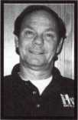

to employ five 1

John W. Soderland, CML, CMST

Hi, I am John Soderland, and I am running for North Central  
Director.

I started to learn locksmithing while in the U.S. Navy in 1970. My  
first job as a civilian was for a locksmith shop in Milwaukee,  
Wisconsin, where I worked for 16 years. In 1986, I started my  
own shop in the southwest area of Milwaukee, which has grown

ll-time locksmiths. We primarily service commercial and indus-

trial clients. I started attending ALOA conventions early in my career. I felt that  
then, as now, the classes are enjoyable and informative. The opportunities to  
meet other locksmiths across the country and world give me a fresh prospec-  
tive on my own business. I owe a large part of my success to the help I received  
from other members in this trade throughout the years. I am motivated to help  
others through the tough times I have already been through. I hope through my  
directorship to repay the kindness shown me. I offer my experience to help  
keep the association strong. I feel the future of ALOA lies in the sharing of  
knowledge and improvement of skills. My representation will reflect the desire  
of our members to advance their trade in the eyes of the public, retain their  
rightful place in the workforce and uphold the integrity as the cornerstone of  
this profession.

8 |

Keynotes

May 2001

**Southeast Region**

"1 James R. Barnhardt, RL

I am running for the position of Southeast Region Director of ALOA. The following is a brief portrayal of my credentials BJfcB to fill this assignment:

been in the locksmith industry since 1975; been a member of ALOA since 1986;

•been a member of SAVTA since 1996;

■Vice President, Economy Lock and Key of Brandon, Inc. - 1995-1997

■President, Economy Lock and Key of Brandon, Inc. -1997 to the present •Member of Florida West Coast Locksmith Association, 2000;

■Voted 2nd vice president, 2001;

•ALOA volunteer 1997, 1998 and 1999;

■Spent six years as a volunteer firefighter.

I ask you, the members, to vote for a member who will take it upon one­self for you and vote for someone to represent your thoughts, ideas and feelings to the Board.

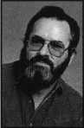

Don Rule’, CML

I have been an ALOA member since 1986. I own and operate Boardtown Locksmith. I am a past president and life member of the Louisiana-Mississippi Locksmith Association and the International Association of Investigative Locksmiths.

In 1989, I was awarded a convention scholarship and in 1996, was appointed as a member-at-large on the ALOA Board. I have served as a Southeast Region Director since 1997.

As a member of ALOA's Legislative Action Network [LAN], I have appeared before legislative committees representing your concerns. I believe ALOA should serve the locksmith by raising the level of professionalism through education. On that note, I sought and won election to the board of the ALOA Scholarship Foundation for a two-year term, which takes effect at the end of convention this summer.

In an effort to allow more member input, I formed a membership council solicited by e-mail for interested participants. Before each board meeting, ALOA members are polled for opinions. Participation is open to all southeast ALOA members.

I would like to continue to represent your interests as your Southeast Region Director. Your vote would be appreciated.

TURPI tO

WHOLESALE SERVICE

**800-848-9790**

**One Call  
Gets You...**

**Amsec**

**Gardall**

**•**

**Hayman  
Me Mink**

**Victor**

**•**

**Winchester**

**Plus Free Delivery  
From America's  
Largest Inventory  
of Safes.**

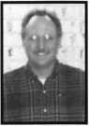

Vincent Formon, CML, CPS

I have been an active member of ALOA since 1987. I am the owner/operator of Town & Country Locksmiths in Memphis, Tennessee. I am the former education chairman of the West Tennessee Chapter of ALOA and former treasurer to the Tri-State Locksmith

Association.

I am presently seeking the office of Southeast Director of ALOA and would appreciate your support. The three most significant things in real estate are "location, location and location," but in an organization such as ALOA, the three most important things are EDUCATION, EDUCATION, EDUCATION! I plan to make education my top priority and will work with the other Board members to make sure that we maintain good quality classes at affordable prices. Please participate in your association by placing your vote for Vincent Formon, CML, CPS and Don Rule', CML for Southeast Regional Directors. Thank you.



SAFE CORPORATION

MANUFACTURES OF QUALITY DEPOSITORY SAFES AND CHESTS

DISTRIBUTING FROM WAREHOUSES IN

* LOS ANGLES, CA
* CHICAGO> IL
* GLASSBORO, NJ

A & B is now a stocking distributor

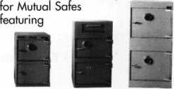

AB-43035 AB-9FL WS 10-2

Chose from over 75 models in stock

We ship your order within

24 hours

See us

*at [www.a-bsafecorp.com](http://www.a-bsafecorp.com)*800-253-1267  
Fax 856-863-1208

CALL FOR YOUR  
CATALOG TODAY

J9

***May 2001***

Keynotes

**Southwest Region**

|  |  |  |
| --- | --- | --- |
|  | Gordon R. Racine, CML |  |
|  | In October 1980,1 started my career in the locksmith pro­ |  |
|  | fession by opening a Lock & Key service out of my home. | f I  Ljk |
|  | 1 worked part time for seven years before my locksmith |
| business became so successful 1 either had to quite my |  |
|  | full time job or my locksmith business. 1 made the right choice! In 1984, 1 joined ALOA, member number 11643, and have attended many conventions and taken advan- 1 tage of the many classes offered. Over the years 1 have |  |

turned a dream into a reality and now have a locksmith & security company with 6 employees that services a trade area of over 50 miles with a population of about 35,000 people. I am currently in my second year as the Southwest Region Director of ALOA. Besides being a long time member of ALOA, I am a member and past president of the Central & Southern Colorado Locksmith Association, and member of the Rocky Mountain Locksmith Association. I believe in community participation and am a member and past president of the La Junta Kiwanis Club, as well as a member of La Junta Chamber of Commerce. Volunteering is my way of giving back to the community and the locksmith industry. We have a proud industry and history. Together it can only get better.

Julie McCluney, CRL

ALOA Member 22 years. President of Hill's Bros. Lock  
Safe, Inc. and Keedex, Inc. Graduate of Loyola Marymour  
University, Bachelor of Science - Business. Julie specialize  
in business management and marketing. Certified ALO,  
Instructor. Wants to bring creativity to the Board.

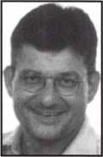

John A. Ilk, CRL

I am currently ALOA's Southwest Region Director current living in Tempe, Arizona. A former chairperson of the Gran Canyon Chapter of ALOA, my memberships include th President's Club and the Legislative Action Network. IV vision for ALOA revolves around education and communici tion. Considering the wide geographical ALOA membe ship base I see the need for more ACE classes and the nee for an expanded, enhanced and robust website that w

inspire members to communicate and enrich their lives.

SET YOUR GOALS HIGH!

The NMLA Convention and Classes 2001

June 14 - 17, 2001 • Best Western Swiss Chalet Inn • Ruidoso, New Mexico

* Thursday Golf Tournament • Saturday "Pan for Gold"
* Friday Night Gala • Sunday Awards Breakfast andMembershipMeeting
* Friday and Saturday classes • Sunday PRP and STPRP to be administered by ALOA
* Saturday Trade Show and Reception



• Servicing Aluminum Storefront Doors  
• Exit Devices

• Domestic and Foreign Automotive Lock "Field Service  
• "High Security Automotive Lock"Field Service"

• Basic Locksmithing

• Fundamental Impression and Picking Techniques



May 2001

10 | ***Keynotes***

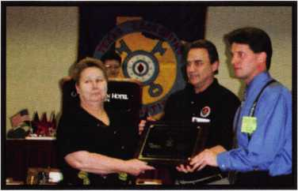

TLA President, Patricia Titus presents the prestigious Longhorn Award to ALOA in recognition of dedication and service to the betterment of the locksmith industry.

On hand to receive the award were ALOA past president David Lowell and ALOA Northeast director Jack Magee, III.

Letter to Editor:

The letter from last month sent in by Chuck Pigue of Seattle Washington (April 2001, pg. 10), discusses a prob­lem about running into some asbestos at one of his job sites at a base.

For starters, they shouldn't have run into any asbestos; way back in the 1980s, all government agencies were to be inspect­ed and any asbestos was to be removed (EPA and DOD mandate). I know because I was in the service when the orders came down the pike.

I served as a hull technician, and part of my training was in asbestos removal, though we were limited to ship board emergency situations. Otherwise, we were to leave it to civilian contractors. As far as I'm concerned, tell the Navy to forget it. If the contractors forgot about the doors, it stands to reason they forgot about other areas as well. And as a lock­smith trained in this area, my answer about doing this sort of work would be "No." The reason is that I received my training in the Navy; to get such a civil­ian certification would cost a bundle and that's not counting the cost of the equip­ment that you need to get the job done. One other thing to remember is that short term exposure to this material (akin to coal dust) is not hazardous to your health. If asbestos problems like Mr. Pigue's persist, tell the bad guys that people who live in glass houses should­n't throw rocks.



**

Weighs” in BI6I



Enjoy the new technology from ABUS!  
Using the 83 Series Pinning Window™ Cylinder!

**NEW**

• Z-Bar®

OLD

OLDER

Order the **NEW** “83/55” in any keyway from

your distributor! Receive a **FREE** ABUS ($7.99)

Trigger Lock for each # 83/55 ordered! **That’S a 55% Savings!**

Unique  
“Tear Drop”

Design

* Yale 8®
* Kwikset®
* Schlage C®
* Schlage C-L®
* Corbin®
* Sargent®
* Arrow®
* Russwin®
* Weiser - Falcon®

#83/55

order

**HURRY** while supplies last! Promotion ends - June 30, 2001

For ordering information:

ABUS Lock USA 1-800-352-2287

■ ir AArv%

(ABUS)

(ABUS)

Ni.83/55 v ^

HARDENED **.8 3/50

***May 2001***

Keynotes

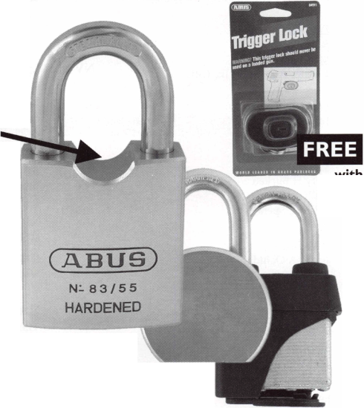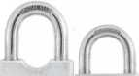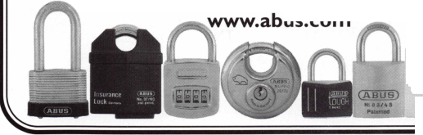

**membership**

AL Auburn University

Melanie R Woods Slocomb Lamar Watford

CA Hanford

Edwin J Vonderbeck La Habra Ken M Ferreira Pasadena

Stephen R Plunkett Reedley

Robert B Auernheimer Santa Fe Springs Bruce N Rice Sr

CO Canon City

Phillip N Poindexter

CT Fairfield

Salvatore Siconolh Meriden

Chester A Dumont Jr., CRL

FL Fort Lauderdale

Julio C Souza Sarasota John P Bello West Palm Beach Rory H Burken William E Davis Kevin E Spencer

HI Honolulu

Justin A Ochida Melvin T Shitagi

IL Chicago

Jorge O Martinez Hinsdale Earl W Lamb La Harpe James R Creasy

IN Danville

David T Walker Gary

Kenneth J Smith

LA Natchitoches

John Whittington

MA Weymouth

Richard J Weisse

MD Baltimore

Jeffrey D Cole John D Phillips CRL

Brian L Ganzzermiller

Ml Detroit

Ted M Adcock Ypsilanti Kelvin Marston

MN Minneapolis

Larry D Johnson

NE Kearney

Lee W Rowedder

NJ Bayonne

Joe M Pineiro Red Bank Scott J Miller River Edge David J Kuhles

NV Las Vegas

Rodney D Hudson Kaye E Slack Ronald M Jayne Ariel Rivera Micheal W Alamo

NY Brooklyn

Philip Mazzone Nvack

Wendy L MacDowell Queens Village Michael Wolfson

OH Marysville

Thomas M Iiams Toledo

Kenneth S Adkins Van Wert William R Good

PA Lititz

Brandon T Graver Philadelphia Shawn W Nelson Ouarryville Lee E Lambertson

TN Knoxville

William G Caryl Michael P Horn Lenoir City Jason D Lane Sevierville

Joe E Crisp Mr

TX Austin

John Hernandez Troy Jensen Joey Molina Chris Smith Joe E Grier Matthew Morris Rudy Lopez Jerry Lopez Jerry Lopez Jr Joshua Randall Steve Guzman Jayme Wilson Mel Langenberg Jon Roden AndyJ Cothron Adam K Black Alex Golden Dallas

William E Clark Del Valle Arthur Mendez Georgetown Kevin Stark Kyle

Fernando Castillo Pflugerville Robert Fleener Chris Chase San Antonio James W Ackerman Wichita Falls Mickie S Croxton VA Centreville

John D Taylor AHC Manassas Shawn M Purvis WA Brinnon

William T Straub CML Kennewick B Scott Dunham Seattle

Brian M Beard Bahamas Nassau

Alexis Gibson

Bermuda

Bermuda

Theresa A Pratt Pedro

Israel

Netanva Jacob Jorgi

Mexico

Guadalajara Hector Q Reyes

Keynotes

May 2001

Kwok-kei Leung

Toshihiro AsANO

Henry W Raymond

Yuriko Yanai

Mary S Ohmit CPL

Charles C Robertson CML

Jack Hobbin

William B Neff CML

Salvatore J Dulcamaro CML

Myeong-Rae Cho

Dana L Barnum CML

Barry K Leas CRL

David M Lowell CML, CMST

Danny W Rudd CPL

Larry A Warnick CML

Jeanne G Lodge CML

C Allan Halveerson

Breck H Camp CML

Dallas C Brooks

Lawrence F Smith Jr, CML

Anthony J Ramunno CML, CPS

James M Watt CML, CPS

Jeffrey S Nunberg CML, CMS

J Thomas Hood

Jim Williams

James H Glazier Sr, CML Robert H Stafford CPL William Lee John C Elliott Jr, CML Scott L Henke CRL, CPS Jerome L Cohen CML Peter K Gauthier CPL, CPS Robert F Carroll CPL Elvis D Hammerschmidt CPL Robert D DeWeese CML Marian M Swann CRL Diana R Barnum CRL Man S Seo

James J Cawby CML, CPS Eugene R Altobella Sr John L Shandy CML Hans Mejlshede CML John S Dorsey CML D Michael Robinson CRL Robert W Duman Sr, CML Philip A Rovenolt CPL Michael B Groves James E Fowler Sr, CML David C Harris CML Peter R Hall

Thomas G Vandersteen CML, CPS

William P Grant CRL

Keizo Takahashi CRL

Evelyn V Wersonick CML, CPS

Joseph P Ferrero CML

Gary F Teams CPL

Michael D Robinson CRL

Brian J Reetz

Maurice Benson

Walter W Lascar RL

William J McElheney CML

Jon B Griswold CML

Russell P Fuller CRL

Daniel L Landry Jr

202

108

100

68

66

65

51

43

40

38

35

35

34

31

31

31

31

27

27

26

26

26

26

26

26

25

25

25

24

24

23

23

23

23

23

22

22

22

21

21

19

19

19

19

19

19

19

18

18

17

17

17

17

16

16

16

16

16

16

15

15

15

15

15



The Brightest

And The Best.

Robert C Rodocker CRL  
James E Gruber CRL  
Michael E Jordan Jr, CML  
James T Brickler CRL

Joseph C Fuller CML, CMST  
Leonard J Passarello CPL  
Frank D Hartung CML  
Joseph W Whitaker CPL  
Robin A Horsley  
Paul M Souber  
Donald H Shiles RL  
John A Ilk CRL  
Richard C Sievers  
Joe J Lee CRL  
Ernest W Wright  
Rolando

John D Cannon CML Raymond C Lusk CML John F Engel CRL Eric F Veal

Basil W Shannon CPL

William J Wickward CML

Calvin G Harris CML

Herbert C Dusenberry CML, CPS

Timothy K Chow

John J Greenan CML, CPS

William L Young CML

Dale L Knowles CPL

Thomas J Demont CML, AHC

Alvin N Minor

Gene

Ronald P Riggins CML Lester S Brodsky Larry L Votaw CML Thomas R Smith CPL William T Straub CML Richard T Johnson CPL Dale V Crosby CPL James V Hawley CRL Eugene R Altobella Jr

May 200 **7**

Keynotes

How can I join the President’s Club?

You can earn a membership in this prestigious club by recruiting just 10 new members for ALOA.

*Any ALOA member may participate.

What do I get?

When you recruit 10 members, you receive a handsome blue blazer with a President's Club crest. For each additional five members you recruit, you receive a lapel pin with gold-filled numbers, indicating, your recruit­ing successes.

You also get the satisifaction of knowing that you are helping your association, helping your industry grow, and you are helping fellow locksmiths achieve success.

How do I get started?

Contact the ALOA office for a supply of applications (800) 532-ALOA or FAX (214) 827-1810. One President's Club credit is awarded for each new applicant. Credit is awarded only after the membership application is approved. However, the credit will apply for the period in which the application is received. Failure to identify yourself as the sponsor on the application form at the time it is submitted to ALOA for processing will forfeit any credit.

*ALOA Board of Directors not eligible for membership in the President's Club

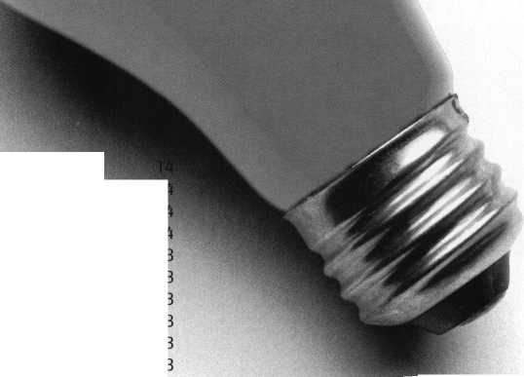

i n h

- /,r7777i

ALOA member Walter E. Webb i locksmith with BANK-LOCK S VICES, Inc. of Alexandria, Virginia.

***Keynotes***

***May 2001***



TT n the Trinidad section of northeast ■ Washington D.C., there is a small two- JL story red brick firehouse that is over 70 years old. This is one of the nations busiest firehouses with fire trucks going out the door on an average of 40 times a day. At this firehouse is stationed the nation's busiest engine company, and as a newly promoted lieutenant, I had just been assign to it. As I walked in the station for my first tour of duty, I was met by Charlie, the wagon driver, “Hey ain’t you a lock­smith on the side?” “On the side” is fire department slang for part-time work, and after hesitantly replying yes, “Well maybe you can open the ol’safe ...or should we just add your name to the long list of failures?” This sounded like a challenge to me; only problem was that I had never done any type of safe work.

ew hours of getting settled in, I

»k at the ol’safe. It is located in a

on the ground floor. From the

several people had also tried to

from the condition it is in, they

) have less safe experience than  
was possible. Over the years, it  
ainted silver several times. The

an” had removed anything and

[ that could be taken off the out-

large box of parts sat on the

first step was to get everything

j^ther. It took me several hours to

thing back in its correct place,

and the lads started to have their doubts  
about my safe expertise. I also found out  
that the handle was missing; this was not  
starting out the way I had hoped.

I called all the past old timers who had been assigned to the house over the years and asked what they knew about the ol’safe. The short of it was that it had not been opened in at least 25 to 30 years, and numerous attempts had been made by sev­eral others over the years to get it open without success. In the early 1970’s, one of the lads had gone down the street to a local locksmith shop and asked about opening the safe. The quoted price was $200, but there was not that much interest in finding out what was in it. So on to step two, I

called several locksmith friends. Basically I found out that I had to identify the ol’safe before anyone could recommend an open­ing suggestion. I went back through every past issue of all the locksmithing magazines at the shop and home, reading all the arti­cles dealing with safes, and was I surprised to learn how much I did not know about them. I took a couple of pictures and start­ed carrying them around with me, and believe me, I asked anyone who would stand still for two minutes during classes and association meetings about the safe. Over the next several months I purchased just about every book on safes that I could find. I learned about hinges, dials, sizing, shape, “T” handles, “L” handles, etc. Finally, I found a similar safe in SAFE OPENING Volume IV by Dave McOmie, and, I believe, the ol'safe is a HERRING Jeweler’ Chest.

LESSON ONE: when you are confronted with a problem or a job that you do not know how to do, call someone, ask ques­tions, look it up in trade journals and books. That is the difference between a professional and everyone else.

Step three was to learn more about safes. I took a class on basic safe servicing. During the class it was suggested that with a safe that old I might be able to manipu­late it open. What is that? So I bought more books and then I went and took a hands-on class in manipulation. I then spent several hours failing to feel something that was so easy to do in the class. Back to the drawing board. Next suggestion was to use audio amplifier, so I borrowed one. I waited till late at night one tour to try and hear some­thing that I had failed to feel. It was amaz­ing what I could hear, the flourescent light fixture buzzzzing, the traffic passing by outside (including several horns blowing), and then an emergency response came over the vocal alarm. After a couple hours the ringing in my ears stopped.

Picture 1: The Polaroid that I showed everyone.

LESSON TWO: Read and understand all the directions before using any tools.

May 2001

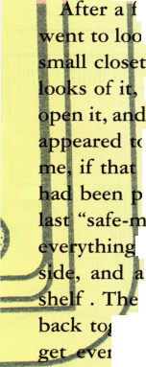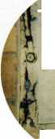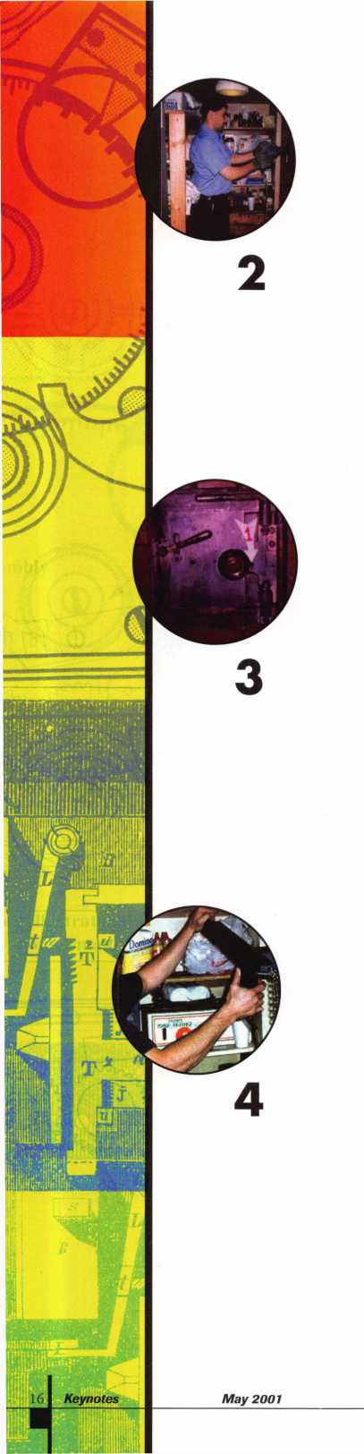

Well back to step two, and back to asking questions. With more reading, I found out that I had a rare Dextor lock on the ol’safe. This type of lock has a five number combination, the fourth number is pre set to line up a split driver, and is very hard to manipulate open. At this point I have decided that it is time to drill this safe, and I did not let the fact that I had never done this before detour the planning. I went and got several advertised “drill through anything bits," and after some more reading I made some educated guesses on just how thick this door should be and where to drill, we started. As I stated earlier, this safe is in a small closet, and one could only stand the noise for about ten minutes. There is some­thing to be said for the hearing protection recommended in the drill’s directions. So the lads all took turns in the hole. Well after about ten hours of drilling and around ten drill bits later we had a nice hole, and it was almost three inches deep­er than I guessed.

Picture 2: “Gordo” and his 14 pound guns taking a turn in the hole.

Picture 3: The first hole completed!

Now what? Ask more questions. “Use a scope, line up the wheels and transfer the numbers to zero." I can do this, so I borrowed a scope. Next tour I looked in the hole, but I do not see any wheels, in fact I do not see anything. At this point it is a good time to point out lesson two again. Also I have decided to drill another hole, but the lads are quickly losing some faith in my skills.” Let me get this right - the book said drill here, but you think you want to drill over here? Have you ever done this before?” Well, at this point I explain I have never done any safe work.

LESSON THREE: Never give up!

Back to the hole, and after twelve hours of drilling (I lost count of the number of drill bits) we had a hole about one inch deep, only three more inches to go. I called more people; one reply, “It’s supposed to be hard to drill a hole in, that’s why they call it a safe.” I am sure that in a safe this old there cannot be any hard plate ...right? Well the next suggestion is we need more pushing power... right, we have already drilled one hole without a rig. “Well even a blind squirrel finds a nut once in a while ....” So I build a simple rig out of two inch angle iron and chain.

LESSON FOUR: Frustration is the true mother of inventions. Picture 4: “JD” shows off the home-made drill rig.

Well the lads have started betting against a successful opening. We start drilling again, and we are through in about two hours, and with only one drill bit. It is amazing how well things work when they are done the way they are supposed to be done.

Picture 5: The second hole is completed!

Well my theory is to punch the bolt and retract the handle, and with some more educated guesses I am sure I have figured out which way the handle needs to be turned. As I hit the punch, one of the lads is applying pressure to my makeshift han­dle. After several good hits and nothing is happening comes the reply, “Hey it sure don’t turn far that way, but it does go almost half way around towards the other direction ....” Well, the ol’safe was open ....and empty except for letter of resigna­tion dated in 1949.

Picture 6: It is open! ....and look in the top right hand corner of the lock case.

It had been drilled before. Also notice that the first hole was in the correct loca­tion.

Well much to my surprise, the first drilled hole was exactly where it needed to be ....so how come I could not see any­thing? When I removed the lock case cover I found out that the shavings had filled in the hole. If I had known, I could have probably just blown in the hole and cleared the hole.

LESSON FIVE: Know what you are look­ing for, and what to do when you do not find it.

It sure would have saved me a whole bunch of time and money. From the looks of it, it had been drilled open before in the upper right hand corner which would allow you to line up the gates with the fence.

Picture 7: The safe back in service with a new handle and Unican lock. This also took a while, and another bunch of ques­

tions, but that is another article ....

The door was repaired, painted and it has a new handle and new Unican lock. This also took a while to complete and involved asking more questions, but it is back in service. Well the whole job took me about two years. I spent hundreds of dollars on books, classes, and assorted tools and drill bits. It's probably a good thing I am a firefighter full time; I may need a little more experience before I hang out my “SAFE-MAN” shingle. Well some thanks are in order; to Mr. Roland Phillips, Mr. Philip Rovenolt, Mr. Don Shiles, Mr. Luke Dennis, Mr. Donald Drury, and Mr. John Burger who were kind enough give me several private con­sultations. To Mr. Jim Workman of Blaydes Lock Co., thankfully they where just up the road from the station. To the lads of Engine Company #10 who despite an average of 30 runs a day were always willing to lend a hand. And last but not least, to Frank, Harry, Tom, and Toby of Bank-Lock Services in Alexandria who had to listen to every detail every time I was at the shop, plus they lent me all the tools

FINAL LESSON: Remember to thank everyone who helped you, and remember this when someone calls you with a ques­tion!

**About the Author:**

ALOA member Walter E. Webb is a lock­smith with BANK-LOCK SERVICES, Inc. of Alexandria, Virginia.

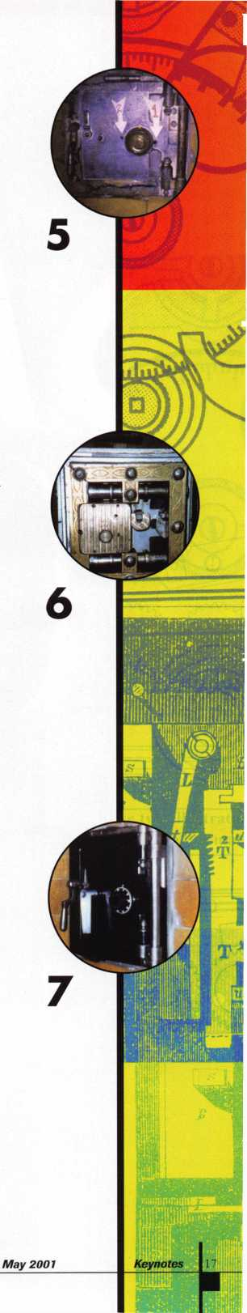

ELECTRONIC



Keynotes



May2001

1. can quickly think of over 30 electronic safe locks on the market today. These are locks that will retrofit the standard footprint for mechanical locks and dial rings. The number grows further if I count the electronic safe locks that are incor­porated into the safe door design such as you find on Sentry, hotel safes and many of the small imported home safes. What is my point? Well, for those that are consid­ering doing work on safes and especially on electronic safe locks the question is where to begin. How does one begin to learn about electronic safe locks? Is there a class or school that can teach all of this? No!

I think the best approach to electronic safe locks today is learning about those models that you are most likely to encounter in your day-to-day work. I am referring to the locks you see on show room safes, in the literature from the safe manufacturers as options on their products and a few additional locks worth considering as replacements onto existing safes.

Using this approach you can begin building a reference book. I suggest you label a thick 3-ring binder, insert some dividers with identifying tabs and begin to collect informa­tion on each model lock. I have included a chart of 1 3 of the most popular locks that sell to the locksmith for less than $200 and range down to about the $65 level. Included in this chart are models that have become standards from the safe companies and some of the newest models on the mar­ket. You can use this chart as the basis to start you reference book and begin to collect operating instructions, program­ming instructions, installation instructions, magazine articles, templates and information you have printed from the internet sites. One valuable site to visit is the Clear Star Security Network where you can access valuable tips and other information from its members on the Safe Tech Forum that is the official site of SAVTA. The members of Clear Star are sharing information on all models of electronic safe locks almost on a daily basis. Tips on troubleshooting and drill points for when total failure occurs and the safe must be drilled.

Think of electronic safe locks as you would after market options for an automobile. You would select from many dif­ferent styles of stereo models based on many factors. Cost, performance and features would undoubtedly be the main factors in your consideration before making the purchase. We have established the cost range we are considering and we will assume similar performance and dependability. Features are the remaining factor and the chart will supply enough information for you to narrow the choices to just a couple. What the chart does not provide you with is the smallest details and here you will have to contact a distribu­tor or perhaps the factory to learn more.

H

The features that are included in the chart need explain­ing so we all agree to what the descriptions mean. The chart uses the term bolt action and this is asking whether the bolt requires retraction and extension by means of the oper­ator turning the outside housing or if the bolt will be auto­matic. While manual bolt retraction is more conducive to attachments the automatic ensures the operator never leaves a safe unlocked. It is easy for someone to close the door, turn the handle and forget at the end of the day to lock the lock by rotating the outside housing.

A field convertible bolt is a patented feature of the llco 51 5 model whereas the bolt can be set to deadbolt or spring bolt action. The removal of a steel dowel from the end of the bolt converts the bolt to spring bolt action.

The quantity of users refers to the number of combinations that will open the lock. In some locks this will include the master code and in some locks the master code, super mas­ter code and other names does not operate the lock.

Time delay is self-explanatory but the delay opening win­dow is the period of time at the end of the time delay peri­od in which the operator must reenter their code in order to open the lock. If this time frame (opening window) expires without the code being entered the lock will reset to the idle condition and the time delay period will have to be started once again. Notice that some locks have a set value for the delay opening window but most allow for a choice of time values to be programmed.

Dual custody mode is a feature whereas the lock will require two codes to be entered before the lock will open. When dual custody is coupled with time delay, only one code is required to start the time delay but two codes are required to be entered during the delay opening window before the lock will open. Some locks will require the couri­er or cash pickup service to be included in dual custody when that feature is activated.

The duress alarm interface is often called silent alarm mode also and simply means that the lock can be connect­ed to the building alarm system. In the event of an emer­gency, namely a robbery, the code can be altered and the alarm is 'Tripped" thereby notifying authorities or the moni­toring service.

A lock disable input allows the operator to disable the lock or "shut it down" and one method is through the connection to the alarm system. Once the alarm system is turned on (armed) the locks power circuit is disrupted and hence the keypad rendered "dead" until the alarm system is properly turned off.

The bolt sensor switch is an optional switch that monitors the locks bolt position, whether extended or retracted, and either opens or closes a circuit. The status of the circuit will

***May 2001***

Keynotes

|  |  |  |  |  |  |  |  |
| --- | --- | --- | --- | --- | --- | --- | --- |
| Features | Mas-Hamilton | Mas-Hamilton | llco | llco | LaGard | LaGard | LaGard |
|  | Model 50/D50 | Auditon 100 | Model 505 | Model 515 | ComboGard | Safe Gard | LG Basic |
| UL Listing | Type 1 | Typel | no | Type 1 | Type 1 | Type 1 | Type 1 |
| Access Method | 6- digit comb. | 2- digit ID plus 6-digit | 4 to 7 digit comb. | ID plus 6-digit comb. | 6- digit comb. | 6- digit comb. | 6- digit comb. |
| Qty of iocks/doors controlled | 1 | 1 | 1 | 1 | 1 | 1 | 1 |
| Bolt action | manual or automatic | manual or automatic | automatic only | manual only | manual or automatic | automatic only | automatic only |
| Spindless Option | yes | yes | yes | no | optional | yes | yes |
| Field Convertible Bolt | no | no | no | yes | no | no | no |
| Power Source | self- powered | self-powered | batteries | batteries | batteries | batteries | batteries |
| Key Pad | 12-button tactile | 12-button tactile | 12- button tactile | 12-button tactile | 12- button tactile | 12- button tactile | 12- button tactile |
| Display | 2 LEDs | 2 LEDs | 2 LEDs | 2 LEDs | 1 LED | 1 LED | 1 LED |
| Available Housinqs | Round, Vertical, or low-Proflle | Round, Vertical, or low-Profile | Round | Round | Low-Profile | Round | Round |
| City of Users | 1 | 5 | 9 | 10 | 2 | 2 | 2 |
| Time Delay | 5-99 min on D50 only | 5-99 minutes | 1-15 minutes | 1-99 minutes | 1-99 minutes | 1-99 minutes | no |
| Delay opening window | 1-20 min on D50 only | 1 -20 minutes | 3 minutes | 1-9 minutes | 1-19 minutes | 1-19 minutes | no |
| Time Lock Control | no | no | no | no | no | no | no |
| Dual Custody Mode | yes | yes | yes | yes | programmable | programmable | no |
| Wrong Try Lockout | yes | yes | yes | yes | yes | yes | yes |
| Duress Alarm Interface | no | optional | no | 515Donly | optional | optional | no |
| Lock Disable Input | no | optional | no | no | optional | optional | no |
| Bolt Position Sensor | optional | optional | no | yes | optional | optional | optional |
| Courier Override | no | yes | no | yes | programmable | programmable | n/a |
| Audit Trail | no | yes (10 events} | no | no | no | no | no |
| Audit Date &Time Stamped | n/a | no | n/a | n/a | n/a | n/a | n/a |
| Audit Report Method | n/a | to PC via Smart Key | n/a | n/a | n/a | n/a | n/a |
| Superviser/Subordinate Mode | no | yes | no | yes | Programmable | Programmable | no |
| Master Code | yes |  | yes | yes | m | yes | no |

sound an alarm, turn on a warning light, sound a buzzer, trigger the silent alarm, signal the CCTV camera and recorder or activate some other device on the circuit. This option can be quite valuable in certain situations.

Courier override is another name for time delay over­ride and is often used when a business uses the services of a courier service such as Wells Lomas or Brinks for their cash pickup. The courier service is most vulnerable when the truck is stopped and personnel are "on the ground". For this reason couriers do not want to wait for time delay to expire and leave the truck sitting for the 15 minutes or so. Time delay also cuts into the total available for the courier to run their route. Imagine if each and every pick up location was on a 15-minute time delay. At the end of the day the cost of the service would be forced to rise dramatically.

You will notice that a couple of the locks offer audit trail and this feature is important to some customers. I have been told that for audit trail to be admissible in a court case there must be a time and date stamp in the events record. I am not qualified to render any legal advice so my best advice to you is to check on this in your area and be in the know for when the question arises from your cus­tomer, and it will. One of the locks in the chart reports the audit via a Smart Key to the PC and this simply means

a Dallas chip key downloads the audit trail, and then later uploads that information to the software in the com­puter. The other lock reports the audit trail directly to a laptop computer by attaching a cable.

You will want to keep in mind that many of the locks require extras to be purchased when certain features are in use or to program the locks to some features. These extras may be in the form of software, Dallas chip keys, cables, alarm boxes, attachments or require a computer. Some locks may be programmed by the distributor to "turn on" some of the features. These are some of the details you will want to learn and record in your reference binder. Also, you will want to know that locks have what I call personalities from one manufacturer to another. By this I mean that some locks will allow the buttons to be pressed more rapidly than another brand, different brands have different factory codes and programming steps dif­fer from brand to brand.

I hope it goes without saying (but I will say it anyway) that taking classes is the most important step to learning about electronic safe locks. You will find these classes offered by your local or state association in addition to the ALOA convention this July in Baltimore. I hope I see you there.

Keynotes

***May 2001***

CHART IMAGES

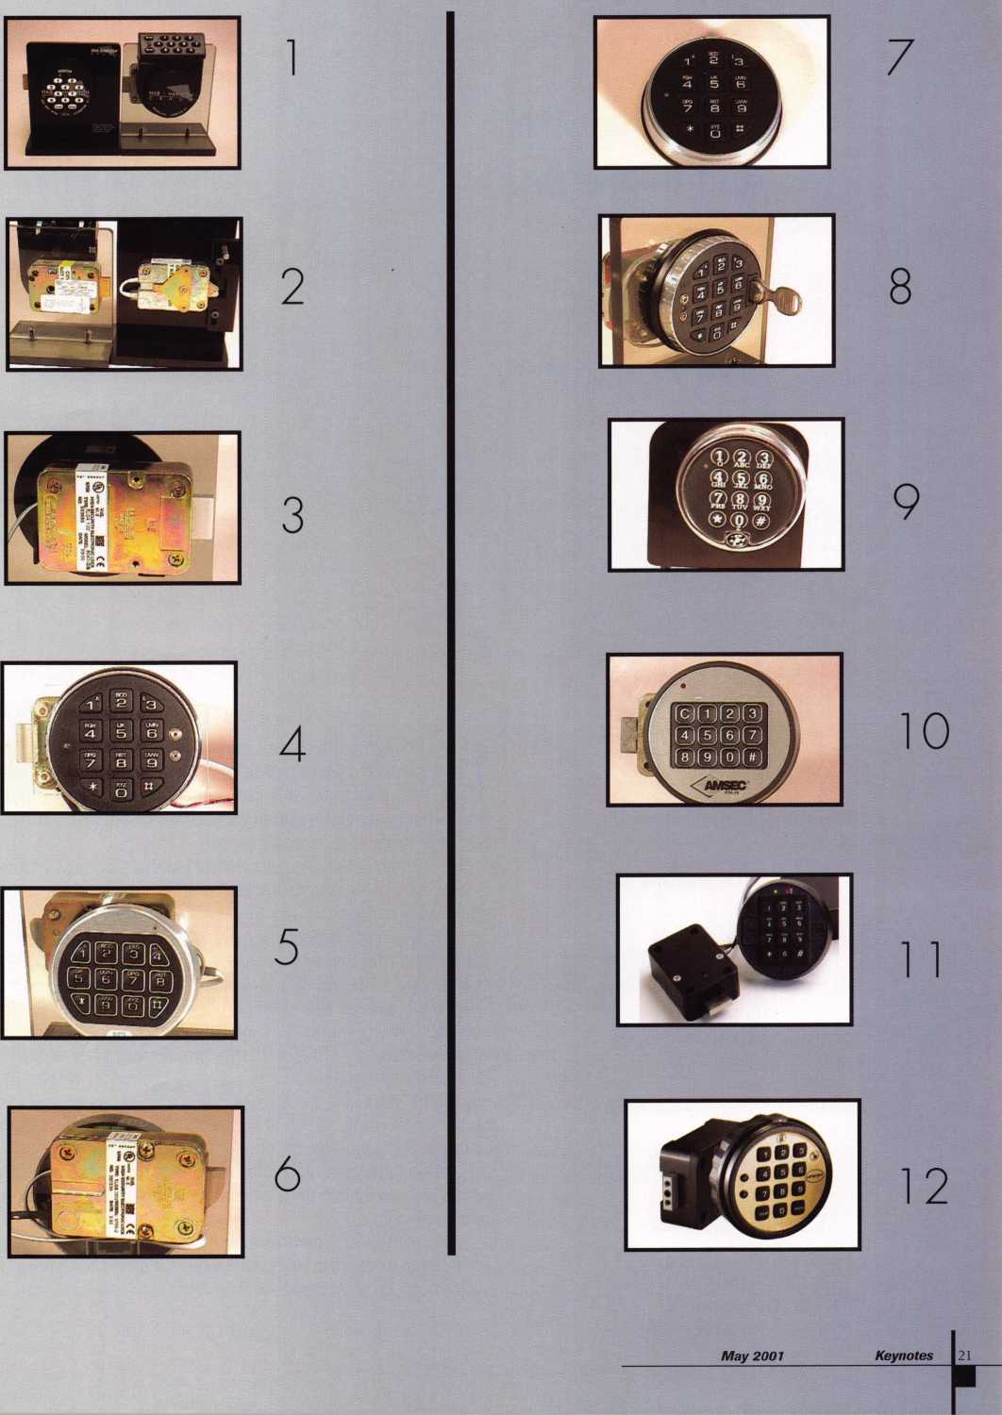

I

f you do automotive work and have not had the opportunity to expe-  
rience the GM MATS column, you will eventually. Of course, the first  
time you encounter this column, the vehicle will be parked with the

front wheels against a parking lot barrier or against a curb. No problem,  
with this technique, it won’t matter.

The column looks almost identical to the standard GM tilt column. It is, however, quite different internally. The differences are all tied to the anti-theft system built into this column by the manufacturer. There are some major parts difference. An anti-theft ring has been installed over the locking ring beneath the steering wheel to restrict access to the lock mechanism. The ignition lock itself has been redesigned with a larger lug at the pin of the retaining bolt opening. Strattec part number 703342. This column also utilizes a redesigned inner lock housing, which accepts an anti-theft collar preventing easy access to the sector gear and rack system (this is normally broken by thieves during a vehi­cle theft.) Some of the Minivans are also equipped with what is called an interlock cable, which is connected to the ignition linkage rod. Most of these parts will not be encountered by locksmiths, only by the peo­ple making the actual column repairs. The parts normally associated with the locksmith during normal service will be the lock itself, and the anti-theft ring.

Although I do the actual column repairs to the vehicles that have been stolen, the technique I have learned to bypass this anti-theft system can be used by any locksmith. Once you have learned to use this

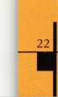

Keynotes

***May 2001***

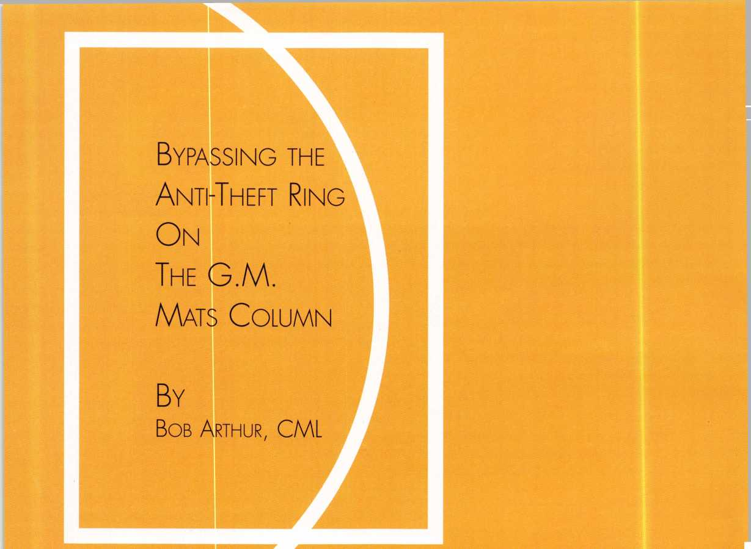

Anti - Theft Ring

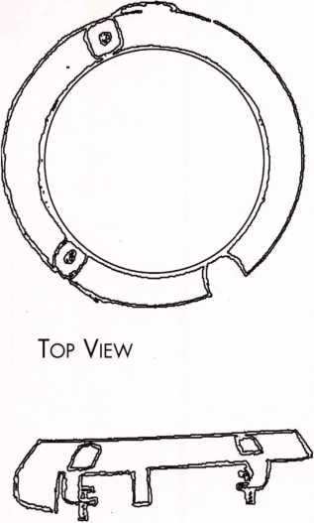

Side View

technique, and have done it a couple of times, you will find that servicing this lock can be a breeze. It also has the added bonus of dazzling your cus­tomer and giving a professional air to your service. This allows you to charge more for the service, and leaves your customer feeling that he truly hired the services of a professional. Lets face it: Professionalism is what separates us from the retired factory worker that decides to supplement his income by becoming a part time locksmith. Yes, he may do it cheap, but can he do it right? You can assure your customer that you can repair his problem without further damage to his column.

The GM MATS [Mechanical Anti-Theft System) column is used on the 1993-1994 Trucks, Mini-Vans, and Sport Utility Vehicles. This Column is equipped with an Anti-Theft ring located directly beneath the steering wheel. This part is held in place by two Torx head screws, and covers the standard locking plate used on most GM vehicles. In order to access these mounting screws, the steering wheel must be turned 180 degrees from top dead center.

If you do not have a working key, or the ignition lock is damaged, it can be very difficult to align the locking plate into the proper position to access these screws. The locking plate on this particular column has two cutouts are larger than the locking grooves, and are designed to allow access to these screws. When the wheel is turned to the proper position, the large openings in this locking plate are aligned over the screws at approximately the 8 and 11 o'clock position.

The problem develops when the lock cannot be turned, and the steering wheel moved to the proper position. When the steering wheel is removed, you are faced with this anti-theft ring. Directly beneath the anti­theft ring, the locking plate is being held in the locked position by the lock­ing pin. Although there is an access hole in this anti-theft ring to access the locking pin, without the steering wheel on, how do we turn the shaft. ? There are several ways, and several tools designed to do this; however, I have found the following to be the simplest.

One bolt connects the lower end of the column shaft to the shaft coupling. This is normally located under the hood where the column comes through the firewall. It will either be 15mm, 13mm, or 7/16 in size. Let us take a step - by - step walkthrough this procedure. From pulling the wheel to replacing the lock, we shall try to cover each step. Once you have done one in this manner, I believe you will find it the easiest and fastest way to bypass this obstacle.

Begin by removing the steering wheel. The horn pad will be attached by either two 9/32 screws, or simply pulls off. Disconnect the horn wire by pushing in and turning to the left. The wire is under spring tension, and when turned as described, will simply pop up out of the hole. Remove the 13/16 nut, attach your wheel puller, and pull the steering wheel. Once removed, you will see the anti-theft ring covering the column locking plate. Next, raise the hood, and locate the coupling connecting the intermediate shaft to the lower column shaft. Remove the bolt connecting the coupling to the column shaft. Once the bolt is removed, tap down on the coupling with a small hammer, until the coupling slides off the column. If you fear getting the shaft and coupling back together in the wrong position, simply make a mark on the surface of the column shaft, just above the coupling, this will assure proper alignment when you reassemble. Once the coupling has been separated from the column, you are ready to continue.

***May 2001***

Keynotes

Go back to the top end of the column, and seat yourself as if you were getting ready to drive the vehicle. Looking down upon the column, you will notice and opening in the anti-theft ring in the upper left, or 11 o' clock posi­tion. Using a hook tool, or an ice pick bent about 1/2 inch on the end, place the hook through this opening facing to the left. By fishing around a little, you can find the locking pin where it protrudes through one of the grooves on the locking plate. Work the tool around until you can depress this locking pin. You will be able to feel spring tension pushing the pin up. When you feel the spring pushing against you, you will know you are on the top of this locking pin. Depress the pin, and with your other hand, turn screws on the anti-theft ring. (These screws DO NOT COME OUT.) The screws are designed to stay in the ring. Once the screws have been completely loosened, the anti-theft ring can be lifted off. Since the column has been disconnected from the lower shaft, the column shaft will turn easily with your thumb and fingers.

Once the anti-theft ring has been removed, you may then remove the locking plate using your compression tool. The locking plate is held to the shaft by a snap ring. It is only necessary to compress the locking plate enough to remove this retainer. Forcing the locking plate down too far can result in a bent locking ring, broken canceling cam, or broken turn switch. I have found that by applying just enough compression to allow a thin blade screwdriver to be placed under one side of the snap ring and applying slight pressure, a hook tool can then be used to pop the snap ring out of its groove. Remove your compression tool and slide the snap ring off the shaft. The locking plate can now be removed. The horn/canceling cam will usually lift off with the locking plate. Next, remove the pivot arm connection (the turn switch to the wiper switch.) This is located on the left side of the turn switch and will be held in place with a flat Phillips head screw. The four-way flasher button is removed next. It is held in place by a small Phillips head screw going right down the center of the button. Note: The flasher button assembly consists of an outer shell, center button, spring and screw. Take care not to lose any of these parts, as the spring has a tendency to fly out once the assembly is removed. The turn signal switch is held in place by either three Phillips head, (most common) or three torx head screws. These screws are visible at the #1, #9 and 5 o' clock positions. You will have to pivot the turn signal cam upward toward the top of the column to gain access to the 5 o' clock screw. Once these three screws have been removed, use your hook tool to gently work the turn switch up and out away from the column, it may be necessary to remove the lower access trim panel and unplug the switch harness. This harness is normally snapped into a bracket on the right side of the column jacket. Push the harness con­nector up and out of the bracket; you can then unplug the harness, and the extra wire will allow the switch to be pulled up and out of the way. If this is required, remember to reconnect the harness and reinstall it into the bracket before finishing the job.

The key buzzer actuator has been redesigned on these models, and are easily broken. The spring on the bottom is no longer accessible with a hook tool or bend paper clip. This part can best be removed by inserting a nar­row flat bladed screwdriver up through the flasher button opening on the col­umn, sliding it under the plastic plate on the right side of the actuator, and gently prying the actuator from the column. Once the buzzer actuator has been removed, the torx head retainer bolt for the lock becomes visible. At this point, you may remove this bolt, and the lock can be removed for service or replacement.

Keynotes

May 2001

After replacing the lock, many locksmiths have trouble inserting the buzzer actuator back into the column. This can be done easiest by removing the key from the lock, or turning the lock to the on position. The buzzer is operated by the small plas­tic tab located on the bottom side of the lock cylinder. This plas­tic tab will slide up into the lock, allowing the buzzer actuator to enter the column. If, however, the key is in the lock, and in the off position, this plastic tab will not slide up into the lock, mak­ing it nearly impossible to insert the buzzer actuator.

Once the actuator has been installed, gently slide the turn switch back into place and install the three mounting screws. Next, install the flasher button assembly, and install the pivot arm connecting the turn and wiper switches. Replace the canceling cam and install the locking plate using your compres­sion tool. Align the locking plate openings for your anti-theft ring screws, and replace the anti-theft ring. You may now insert the key, turn it to the unlocked or on position, and turn the shaft back to the original alignment position with the lower coupling.

Once you have aligned the column shaft with the cou­pling, gently tap the coupling back onto the column shaft. Once the holes are aligned, replace the bolt and tighten securely. You may now replace the steering wheel, taking care to align the mark on the wheel with the mark on the shaft. One final tip that you may find helpful. On most of the truck steering wheels, it is very difficult to re-insert the horn wire after the wheel has been installed. If you unclip the wire from the horn pad, you can insert it into the canceling cam prior to installing the wheel. Work the wire through it’s hole, as you are installing the steering wheel. After the wheel has been replaced, you need only clip the wire back on the horn pad, and reattach the horn pad.

Once the job has been completed, I recommend starting the vehicle, and turning the wheels straight. This assures that everything is in proper alignment. I also check the operation of all switches and levers as well as the horn. Once you have done this procedure and understand the basics of the column, you will fly through this operation.

This procedure sounds complicated, but it really isn’t. Once you have bypassed this anti-theft system using this proce­dure, you will find it to be fast and simple. Time is money to all of us, and fighting with a manufacturer’s obstacle can cost us a lot of time. Give it a try, I think you will be surprised.

Column Shaft  
Coupling

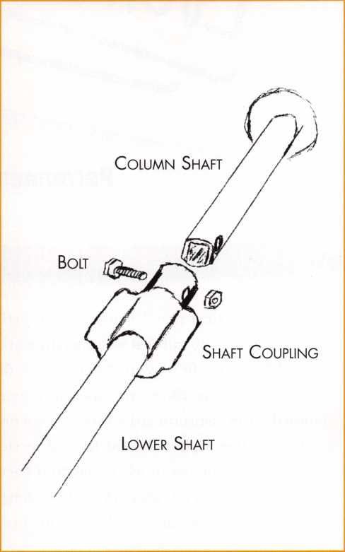

***May 2001***

Keynotes



FT

Ulo

uring the time that I worked as an institutional al locksmith work is the hardware itself, and a lot of

"locksmith, I found that we generally worked with the time, that is unique also.

Grade 1 hardware, (if we were doing it right, thafis)7T

also

imposed on an institutional locksmith. Not only is the (or any institutional maintenance worker) has to learn

hardware different, but also the level of service is dif- to deal with is the number of supervisors that you ferent. Often, the barof whar constitutes acccptable must heed. At a school, not only are you working for performance is much highen JPerfection.some.timesJs your, immediate -boss JauL eyery ieacher, and adminis-

not good enough because it takes too long to accom- trator, and department head that you work around

thinks that he or she is your boss, also. From what I  
have learned over the years, it is not a lot different in

plish, yet perfection is all that will be accepted.

In institutional work especially, the customers are dif- a hospital, or any other institution. There are internal ferent. My entire life has been spent in one form of politics and primadonnas that a worker must be mind-

service work or another. I have always dealt with cus- ful of when doing institutional work. The trick is to

customer service. Institutional work is quite different ignore, and how to do it without offending that per- than anything else that I ever did. The only common- son. ality between generaT locksmith work and institution-

—

Keynotes

i It is really important to learn to not offend people in tomer. Likewise, as it is with most jobs, an employee’s  
;an institution. Mostly, you are dealing with brilliant first duty is to not embarrass their boss. In institu-  
I people who are often dumber than a rock when dis- tionalwork, this is more difficult. If you bring an irate

cussinganytM field.

don’t know that. They haveheemtolcLthatthey are mayeome to rue

(smart and they often believe it holds true about any-  
thing that they do. The people that a school lock- In the everyday world of general locksmithing, if one  
'Tsmlth hasTto'^ "Bis"alw-in with a customer, th^on lo’the ne

[They feel that if they don’t get what they want, when world of an institutional locksmith, one can never  
;they want it, that they are being ignored, and thus leave a customer mad, because they will have to live  
insulted. Whereas, you may be following directions with them forever, and usually, these people have

orretireeariy-Xocksmithstraditionally arethemost

independent, gleefully cantankerous, least political

ed, and take it outj

they probably will be antagonistic to you. If they are

friends with your boss, they will often use that as an i excuse to get special favors.

i A wrong word, or an untactful refusal to do something i requested, can create a bitter enemy from what was an

people in the world. Whether he or she likes it or not, a person working in' an institutionalsetting must be a politician, -and-a-good-ene,-if-they want to survive-for- long, even as a locksmith. People skills, including diplomacy, conflict resolution, and just plain old

otherwise mild-mannered person that can come back Tohauntyouffiuc

: institutional maintenance worker learns ta -use a paperwork order as a shield and buckler against get- i ting mired down in an endless stream of “Oh, while i you are here” type requests that destroy your work schedule; Adherence to established procedure is one

...of the-b£stAQol& that you caiihayg,

! nicely, “If I don’t have it on an order, I am not allowed to do it,” or, “Here is a work order request form. If you IwarfittItoutjTlwD'send’it in for you.” Even so; the

[assigned job done within the parameters given, and keeping the people around happy After all, as in all > service work, the object is to produce a satisfied cus-

“being nice in all circumstances," are the tools of an learruin addition to the physical part of theirwork. _

And the physical part of the work is different also. Emphasis is given to qualify of work, with fhe general implied instructions* being that you do your very best work, take as long as you need to do it, but do it right. That, to me as a craftsman, was one of the pleasures of doing institutional work as a locksmith, or mainte­nance worker. I was often; turned loose without time or-money constraints and. told to-do.the best that 1 could do on the project that I was working on. It is not often in the commercial or industrial world that you are allowed to do your very, very best, lo me, that

*~May~20df*

***Keynotes***



feels good. This is not to say that an institutional lock- opens and closes just right, and makes that indescrib- smith do^ notfwork within a budget. As in all phaiesaBIeT feaflygdod^sbund thaF^acorrectly instilled and of-institutional fife, there will be someone-makingyou-- maintained door does, then you know thattheinstitu- account for every penny that you spend, and scream- tional locksmith has done their job the way it is sup- ing loudly when you submit the bill for some outra- posed to be done. By association, people tend to geously expensive lock or door that has to be replaced believe that if the door works right and is solid, so is ~ — thriiBtiratitmrSveit'the president of thccoll^e’cairt'*-'

Thehardwarethat you dealaKith. as-4in-institutional . give-that first good impression7 but we as locksmiths locksmith is nearly always Grade 1, and very expensive and craftsmen can. To me, this makes the institution- as well as the doors that it goes on. Often, you will be al locksmith one of the most important people in the working "with tRe veryTlest quality doors* made of "TSafityT ~

WdnutfOakf Gherf^^r-etheiHfme-woedsr Tlm-takes-- i—

different skills, and finely honed techniques to do a An institutional locksmith deals with life safety codes. perfect job on this type of door and hardware. A mis- specialty hardware, mortise locks, door closers, panic take when working with this quality door can be very devices and a hundred other things on a daily basis, expensive to correct;”^^lyi3Qryim^erl^'v^“afi ~HfrTjr^SFlS''Tr*lly responsiblefor peopleVlives. A“ “Qpps” plate. You deal with the best of the best school locksmith will deal with more vandalism pro-— because that is what is required. People who design portionally than a general locksmith. College kids and build institutions know that the truest economy is seem to think that it is fon to lock others in a room the very best lock and door." These facilities and'the and then sit back and watch the excitement. I have locks on them jffe- designed to last for ^o years or had to remove more super glue from locks, and wood longer. The workmanship that maintains this level of pencils from door stops than 1 ever care to count. A

building must be equally as good, also. This means knowing the theories, the whys, and the why nots of the'way things are done iff this"discipline.

The institutional locksmith, by what he or she does, projects the image of the institution a thousand times or more a day. Every thing about an institution should reflect strength, stability-solidness, and permanence. Aside from the first view, the first contact with any facility that a visitor has is when that person puts their hand on the doorknob and opens that door. There is whereThe~'fiist\“juidnoft^''p«nnaneht'' impression is made -of that facility When you have a door that

wood pencil forced between the door and the stop at the top or the bottom of an in-swinging door, will jam the latchbolt so that the door cannot be opened from inside. A prankster wiU-catch another student in their room and lock them in this way. Usually the panicked or angered people inside will scream for a locksmith or resort to destroying the lock and door or both.

Super ^ue? What can I say? General locksmiths love__ it. What people do with it only makes us money. For an institutional locksmith, it is a major pain in the cuzod. They ^f pai^tEesame v^uether they have to • deal with this or not. The people who usually wind up

281 ***Keynotes***

***May 2001***

isame people

who arc not a bit bashful about telling the world how

they are being mistreated, and an institutional lock-

locksmith as he is the one who pins the cores for the locks there, keeps the records, and oversees the main- tenance of the system and hardware for the physical

smith does not have the comfort of being able to  
chargeThemextrafortheprivilegeoflisteningrtothem

plant. Andy has taken Best’s classes for IC locks and is

vent.



cylindrical locks.

There is much to protect in a college. Not only does the institutional IbcksnutTf have tEe~r^pdhabiEi^ "for'

dents away from home for the first time, but also, for

''Some'of'Hm makes*it sound like the life' dfan iiiiHtiF'-

reality, it is not more difficult than the things the rest

the physical security of all the records, the research, of us do, but rather it is just different than what other

the equipment and other valuables that a college owns.

a

smith has to secure is staggering. Institutions are..

chock full of the latest in cutting edge technology, all

locksmith disciplines do. An institutional locksmith

of which is very marketable in the outside business worTd. The schooliocksmith is responsible fbf~makihg~ sure thateaehincoming dorm occupant has-afresh, and unused key to their room when they move in. The liability for an incident related to failure to do so

side does^but there are definite advantages to working for an institution. First, the pay is steady, and always there. This is not always the case for a traditional self- ' etn^^yidEr coiiunimion'paidTocksinitii. There is ncT

person, ruthlessly competitive, or even a good busi­nessperson. There are no regular dollar amount quo-

is unimaginable and damages could run into the mil-  
lionsof dollars for an assaulted student. He or she will  
dailymanagea huge masterkey system,usuallyspan-  
ning many buildings and thousands of locks. Key con-  
trol is a big issue, as every teacher there is sure that  
they deserve to carry the Grand Master key and will do  
nearly anything to obtain one. The record keeping

requirement**s are obv**ious, **a**nd daunting,, In times

past, an institutional locksmith did all this on paper.  
Today, there is the blessing of computers and key  
Tracking software.

Today, interchangeable core locks have replaced die  
old Sargent system that was in place at my former  
employer, Navarro College. Andy Barron, maintenance

the function of institutional

tas to meet as are often set in private industry. There  
is no pressure~to produce anything tut good results  
and be dependable.—The institutional locksmith, is -  
more of a pure technician and has the comfort of the  
excellence of his or her work. There are usually excel-  
lent benefits like health insurance, retirement, paid  
vacation, and sick leavethat are often much more gen-  
erous than those same benefits in the private business  
world. The work hours are generally fixed and regular,  
and there is usually overtime, or sometimes comp time  
when you have to work over. An institutional lock-  
smith actually gets to eat a complete meal, and watch  
a whole television show without work interrupting.  
The phone is not nearly so important to an institu-  
tional locksmith. There is much to be said for work-  
ing within this discipline in our industry

***May 2001***

***Keynotes***

P9~

ILCO 54

(

Series Safe  
Deposit lock

by Sal Dulcamaro, CML

ILCO 54 Series Safe Deposit Lock

T

he ILCO 54 series safe deposit lock is  
rekeyable like most lever tumbler [or other  
tumbler based] locks. A safe deposit lock will

typically operate with two keys: a renter key and a  
guard key. The guard key is generally held by the  
bank or other institution that maintains the safe  
deposit boxes. A single nose safe deposit lock will  
have both renter and guard key access the same  
key hole, while a double nose lock will have sepa-  
rate key holes for each key. The 54 series is a dou-  
ble nose, non handed lock. It is shown in photo-  
graph 1. It is double changeable and both the  
guard and renter keys can be changed. In a right  
hand configuration, as shown, the renter key oper-  
ates on the left side and the guard key to the right.  
A left hand configuration would have the position-  
ing and key operation reversed.

The cover is removed in photograph 2. The inside of the lock is exposed to show a less typical construction for a lever tumbler lock. The 54 series lock does not require disassembly or tumbler removal and exchange to rekey the lock. Both the guard and renter keys are resettable with the lock still assembled. The key to the process is the design of the tumblers and fence. Photograph 3 shows the seven flat lever tumblers [from the guard key side] stacked side by side. The location of the gate (unlocking slot in the tumblers] is the same on all the tumblers. The fence, which obstructs a wrong key from operating the lock, is multi-height instead of the more typical straight line pattern. It is the resettable fence that allows the lock to be rekeyed without disassembly or replacing tumblers. The renter side is similarly constructed.

The tumblers are separated in photograph 4. The rearrangement and reassembly of the tum­blers of standard lever tumblers would reconfigure the key bitting. Changing the tumbler sequence here would have no effect. Change is accom­plished with the fence.

Lock Operation

The multi-height fence is held together with a screw that runs from the back of the lock case toward the inside surface of the lock cover. In photograph 5, the tip of the guard key is pointing to the end of the screw (viewable through a horizon­tal slot in the lock] that holds the stacked layers together which make up the fence. To operate the lock, the guard key is first inserted and turned as in photograph 6. If the correct key is used, the gates (or tumbler slots] of the seven stacked lever tum­blers should line up with the multi-height stack of

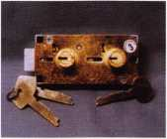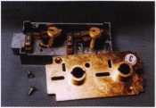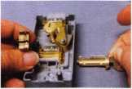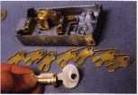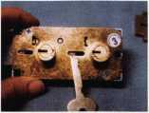

the guard fence. The fence is composed of seven stacked layers locked together with a screw. Each of the seven layers of the fence will coincide with the gate of one of the seven lever tumblers. The

1. guard key does not affect the movement of the bolt, it merely positions the tumbler gates to match the pattern of the guard fence.

Also in photograph 6, you will see the tip of the renter key pointing to the end of the screw for the renter’s fence. The renter key has a dual action. It must first position the gates of the second set of seven lever tumblers to match the seven layer pat-

1. tern of the renter fence. This first part involves inserting the renter key and rotating part way. That action has been done in photograph 7. There are two vertical viewing slots just up and to the left of the two lock noses. A more typical lever tumbler lock with straight line fences would give a clear view of the gates of seven stacked lever tumblers. On the guard key side of the lock, there is the illu-
2. sion of such a pattern, but it is not a straight line. The height range on that side is minimal, but the fence pattern fluctuates high and low over the seven layers. If you look into the vertical viewing slot on the renter key side, it is apparent that it varies dramatically. There is no obvious clue that it is positioned to unlock, but it will.

The cover has been removed in photo-

1. graph 8 to give a much clearer view of the second action of the renter key. The first part of the key’s rotation lined up the tumblers to unlock. The sec­ond part of the key rotation has the tip of the key moving the bolt inward in the direction of the tum­blers’ gates. If either key had wrong cuts, the solid surface of one (or more] of the tumblers would make contact with the matching layer on the fence

***May 2001***

Keynotes

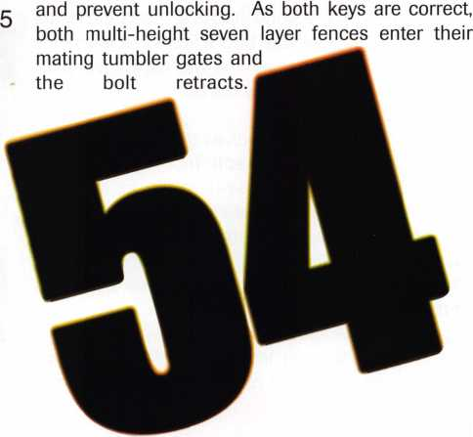

Photograph 9 shows full bolt retraction with the cover in place.

Rekeying the 54 Series Lock

Rekeying a more standard (straight line fence) lever tumbler lock, involves removing the existing tumblers and replacing them with specific sized tumblers that match the new key bitting pat­tern. Different sized lever tumblers would vary by the relative position of their gates (low or high) within the overall height of the flat tumbler. A shal­low #1 depth cut would coincide with a #1 lever tumbler having a low positioned gate. A #5 depth cut, which by contrast is much deeper, would go along with a #5 size tumbler that had its gate posi­tioned fairly high. Since the deeper cut couldn’t lift the tumbler as high as the shallow cut, the higher positioned gate allows for all gates to be raised to one single level to interact with a fixed height fence.

The 54 series lock has fixed height tum­blers which are indistinguishable from each other. The cut depths on the key still vary from each other. It means that when a deep cut doesn’t raise one tumbler as high as a shallower cut is raising anoth­er, the gates in each tumbler are all raised to differ­ent heights. That would make a straight line fence impossible for use in the lock if you used keys with more than one depth.

Changing the Renter Key

It is now abundantly clear that rekeying a 54 series lock does not involve changing the lever tumblers. We will need to loosen the screw that locks together the pattern of the multi-height fence, and alter the height of the various layers to match the pattern of the new renter key. Then the new pattern will have to be held together by tightening the screw.

It is time to get down to specific details. To change the renter key, you will need to start out with the process of operating the lock. The first step is to insert the guard key and rotate clockwise until it stops. The second step is to insert the renter key and rotate clockwise until it stops. At this point, the lock should look much the way we left it in pho­tograph 9. The bolt is fully retracted and the lock is unlocked.

The next step involves getting to the back of the lock, as in photograph 10. The end of the 5/32 inch alien wrench points to the renter fence clamp screw. Directions are reversed because we are looking at the back of the lock. The renter side was on the left from the front, but is on the right from the back. A special change tool/ wrench is supposed to be used to loosen the screw, but I found the 5/32 inch alien wrench to be the right size. With the wrench, loosen the screw 3 1/2 turns counterclockwise. The renter key can now turn a

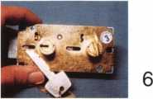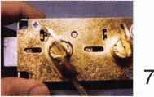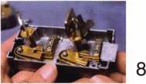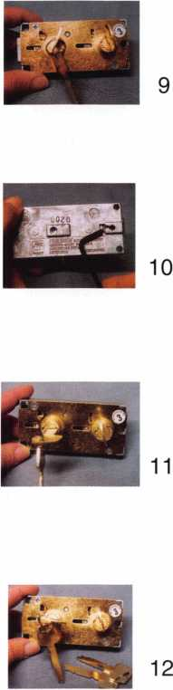

bit further clockwise. Rotate the key clockwise to the change slot position, as in photograph 11, and remove the key.

The current renter key has been removed in photograph 12, and the new renter key has been inserted in its place. The new renter key should be turned counterclockwise until it stops, as in photo­graph 13. The bolt has not been fully extended, and part of the length of the multi-layered fence is still contained within the tumbler gates. Since the screw has been loose, the layers of the renter fence have been supported by the gates of the tumblers.

As long as the layers are contained within the gates, they will remain in a pattern that match­es the key being used at the time. To set the fence to the new key pattern, the screw will have to be tightened. To do that, we will have to go to the back of the lock again. Photograph 14 shows the alien wrench pointing to the shifted location of the renter fence clamp screw. It is important that the key does not move from the stop position while you are tightening the clamp screw. A surface on the lock casting catches onto the head of the loosened screw to prevent the bolt from fully extending before you relock the screw. If you turn the key after only partially tightening the screw, the bolt will extend and the layers of the fence will separate from the gates. A loose screw will allow the fence layers to shift in height, and you may lose the pat­tern for your renter key. So, while in the stop posi­tion with the new renter key, you should fully tight­en the clamp screw. When it is tightened, you can turn the key further to extend the bolt and your fence pattern for the new renter key should be set.

Changing the Guard Key

To change the guard key, you should start out the same way as for the renter key. That is by unlocking the lock with both keys fully turned clockwise. From here, the process changes. Photograph 15 shows the back of the lock again with the alien wrench pointing to the guard fence clamp screw. Loosen the guard fence clamp screw 3 1/2 turns counterclockwise. Then rotate the guard key counterclockwise to the locked position, shown in photograph 16. Remove this key and reinsert your new guard key. Rotate the new guard key clockwise until it stops, as in photograph 17. Then securely tighten the guard fence clamp screw clockwise. As mentioned earlier, it is critical that the key not be moved from the stop position until the screw is fully tightened.

In photograph 18, the renter key has been turned back to extend the bolt, but the guard key is still turned clockwise. In the vertical viewing slot, the guard fence and tumbler gates appear to be in

Keynotes

***May 2001***

alignment. This visual confirmation is not absolute with a multi-height fence, because it is difficult to see layers of different heights further behind. To test that you set the key properly, you will need to try out the keys and see if the lock opens. If one or more layers of the fence shift, you will probably have to disassemble the lock to correct the prob­lem.

The lock instructions indicate that the ILCO Unican change tool must be used or the lock war­ranty is not valid. I don’t have one of the official tools. The 5/32 inch alien wrench seemed to work fine, but not seeing the original tool, I’m not sure how it looks compared to just an alien wrench. My lock suppliers catalog [where I bought the lock] didn’t have the tool listed in the catalog. If I find more information about the tool, I will post the infor­mation on my web page at: <http://home.earthlink.net/~lockwriter>, under “Tech Article Addendum”.

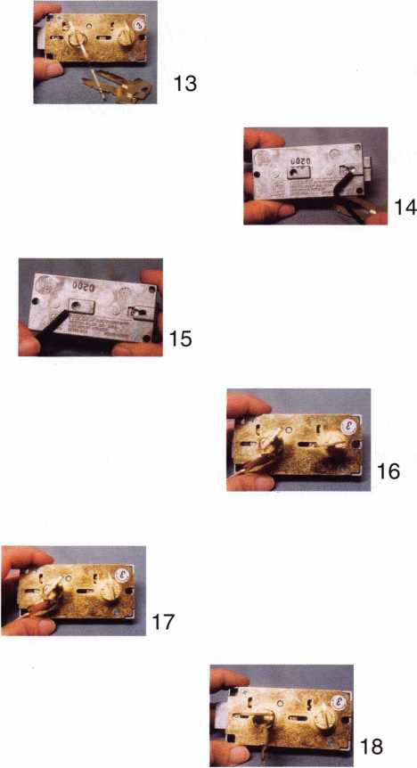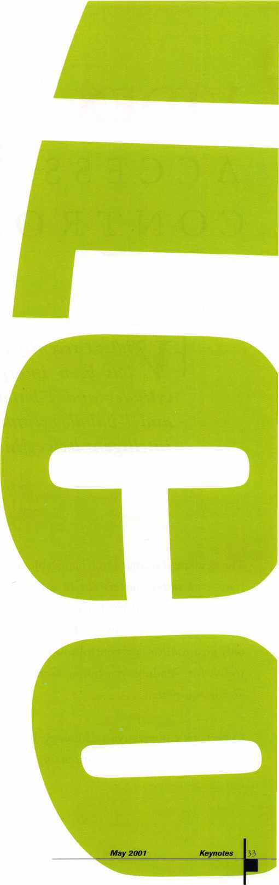

VIDEX

ACCESS

CONTRO

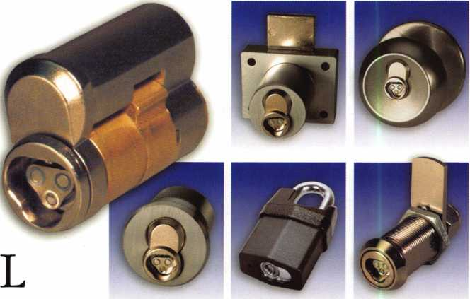

y

idex ( recently announced that CyherLock ) technology  
has been incorporated into the interchangeable core

cylinder and L-handle cylinder. The interchangeable core  
and T-handle cylinders join what is an extensive line-up of  
intelligent lock cylinders in the CyherLock family.

The new small format interchangeable core will facil­itate even faster conversions to a CyherLock access control system, and has been tested with the indus­try’s leading lock hardware. The T-handle offers the only electronic access control solution on the market today for vending machines, coin changers, and arcade equipment.

CyberLock’s innovative technology in lock cylinder design is completely revolutionizing the lock indus­

try. The unique design of all CyberLock cylinders allows you to quickly transform existing mechanical locks into multi-function access control systems, without wiring. The benefits of a CyberLock system are significant. Each key has a unique ID that cannot be duplicated, and the lock cylinder does not have a traditional key-way, which makes the lock pick proof.



Keynotes

May 2001

The first component of  
CyberLock system is

CyberLock cylinder. The  
cylinder is an electronic ver-

sion of standard mechanical lock

cylinders. Installation at the lock is as

simple as removing the existing mechanical cylinder  
and replacing it with the CyberLock cylinder. These  
intelligent cylinders contain a microprocessor and  
memory, and are capable of retaining access pass-  
words, a block key list, and an 1100-event audit trail  
that records user IDs, dates, and times. Since the  
CyberLock cylinder contains no battery, it is ideal for  
indoor and outdoor applications, even in the harshest  
environments.

The CyberKey( is the next component of the  
CyberLock System. This is where battery power and  
access privileges are found. The intelligent

CyberKey powers the system. The^^^^^^£^"* "\

key records an 1150-event history

that includes a cylinder ID,

user ID, dates, and times. The (

key can be programmed to

grant authorized users  
access to specific locks for

specific times and dates, while exceptions such as  
holidays can be preset. In addition, CyberKey can be  
set with a activation and expiration date to prevent  
users from gaining access before or after their project  
has been completed.

For added security in highly protected areas, CyberLock can require multiple keys to gain entry. Locks can be set to require 2, 3, or 4 custody keys in combination. Plus, a delay can be pre-programmed to require the user to wait a specified period of time before access is granted. Finally, in the event that a key is misplaced or stolen, the key can be blocked from all access to the system.

The final component to the CyberLock system is the CyberAudit software. CyberAudit software for the PC is the tool for creating your access control sys­tem. Administrative functions include naming keys and locks, managing locks and keys, defining user privileges, creating master keys and reset keys, and viewing a log of audit events from your PC. You can even keep a file of information on each key holder in your system. A reset key allows you to electronically

|  |  |  |  |  |  |
| --- | --- | --- | --- | --- | --- |
|  | Key Name | Lock Name | Date/Time | Status | ] |
| ► | Joe Wilson | East Entrance | 03/20/2000 06:14:22 AM | Denied | n |
|  | Abby Chaney | West Entrance | 03/20/2000 07:28:03 AM | Key Authorized | |
|  | Pete Sussman | Records Room | 03/20/2000 07:59:15 AM | Out of Schedule | |
|  | John Michaels | Computer Room | 03/20/2000 08:00:03 AM | Key Authorized | |
|  | Evelyn Lefler | West Entrance | 03/20/2000 08:12:16 AM | Key Authorized | |
|  | Juanita Banks | Computer Room | 03/20/2000 08:18:52 AM | Key Authorized | |
|  | Andy Dunsmore | Computer Room | 03/20/2000 08:27:12 AM | Denied | |
|  | Juanita Banks | Chem Lab | 03/20/2000 09:21:45 AM | Key 1 of 2 | |
|  | Abby Chaney | Chem Lab | 03/20/2000 09:21:56 AM | Key 2 of 2 Authorized | |
|  | Pete Sussman | Records Room | 03/20/2000 09:58:33 AM | Key Authorized | |
|  | Pam Freeman | Computer Room | 03/20/200010:12:07 AM | Blocked Key | |
|  | Elizabeth Ward | East Entrance | 03/20/2000 10:21:04 AM | Key Authorized | |
|  | Abby Chaney | Chem Lab | 03/20/2000 11:22:16 AM | Key 1 of 2 | |
|  | Don Acevedo | Chem Lab | 03/20/2000 11:22:28 AM | Key 2 of 2 Authorized | |
|  | Evelyn Lefler | Records Room | 03/20/2000 02:16:33 PM | Denied | |
|  | Les Escobar | Chem Lab | 03/20/2000 03:18:22 PM | Key 1 of 2 | |
|  | Don Acevedo | Chem Lab | 03/20/2000 03:18:29 PM | Key 2 of 2 Authorized | ▼ |

The final component to the CyberLock system is the CyberAudit software. (Screen Shot)

***May 2001***

Keynotes

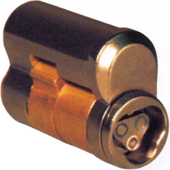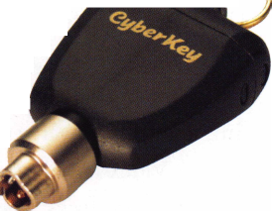

reset passwords in your locks and keys if the security of your system has been compromised. No more mechanical re-keying!

The CyberLock family of intelligent cylinders con­tinues to grow. For exterior and interior doorways, Videx has created CyberLock versions of the mortise, rim, knob, and lever set locks. For cabinets and con­tainers, Videx has electronic CyberLock cylinders for padlocks, cam locks, and vending machine T-handle locks. Each cylinder is designed to the exact dimen­sions of the mechanical lock cylinder it is replacing, which allows electronic CyberLock cylinders to be installed in standard lock hardware in minutes.

Since there is no battery in these cylinders,

CyberLock can go virtually anywhere.

CyberLock cylinders can be

found in padlocks securing

transported freight, chemi-  
cals in storage buildings, or

equipment in outdoor pump-

ing stations. CyberLock cam locks can be found  
securing access to network servers and critical data  
processing equipment. CyberLock mortise, rim, and  
lever locks can be found securing doors throughout  
large institutions and building complexes.  
CyberLocks are being used on cash drawers in banks  
and drawers inside safes at retail stores that require  
reports of every entry.

Videx, Inc. has quickly become an industry leader in the design and manufacturing of access control prod­ucts. Videx designs, manufactures, and distributes products directly from their headquarters located in Corvallis, Oregon. The melding of highly innovative people with the most advanced equipment enables Videx to take a product from concept to production

within weeks.

Videx knows that the ultimate success of any product is in supporting the needs of the customer. To this end, Videx has staffed the customer support team with hardware and software technicians. The power­ful combination of a dedicated customer support staff and advanced manufacturing equipment allows Videx to immediately identify the needs of its cus­tomers, then provide a solution that always meets or exceeds their customers’ expectations. Videx believes a large, satisfied user base is the best sales force any company can have.

For further information you can contact Videx Sales at (541) 758-0521, email address: sales @videx.com, or on their internet site at [www.videx.com](http://www.videx.com).

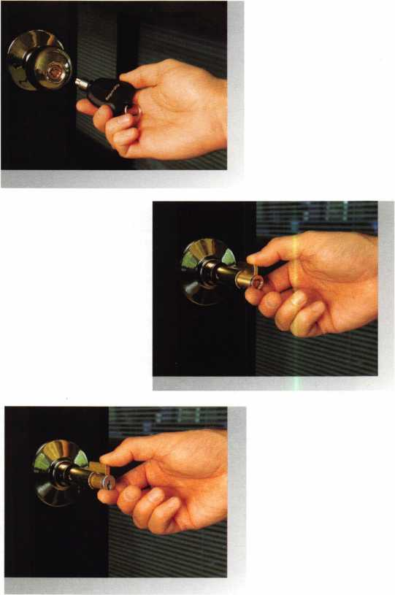

Keynotes

***May 2001***

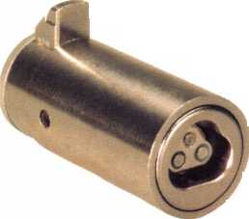

***Power Wedge***

***PW-100***

7 teet long.

HPC, Inc.

3999 N. 25th Avenue Schiller Park, IL 60176 USA Tel: 847-671-6280 Fax: 847-671-6343 [www.hpcworld.com](http://www.hpcworld.com)

***Switch Stick***

***CO-80***

* The special hook design is ideal  
  for flipping switches, lifting  
  buttons and hooking handles!
* The rubberized plastic hook  
  protects car interiors and adds a  
  superior gripping power!

*AutoSleeve™*

***AS-1***

* Prevent damage to weather stripping and automobile finish.
* Show your customers that you care about their car!

•Slip it in! Pump it up! Insert your tool! Open the car!

• Ask for HPC’s Original Air Wedge! Accept no Substitutes!

***The Original Air Wedge™***

***AW-99***

* The Power Wedge does what a pry tool cannot; it props open vehicle doors quickly and safely!
* Made of 14 gauge steel, the long lasting Power Wedge is strong enough to help you open some of the toughest vehicles!
* Ideal for wrap-over doors, the Power Wedge, with its rubber-coated tips, slides in easily and protects the vehicle’s finish.

***5 Foot Super Snare***

***CO-78***

The handles control the wire loop enabling you to grip buttons and handles!

* This flexible tool holds its shape
* The rubber tip protects car interiors and is ideal for pushing power lock buttons.

The Power Wedge allows you to quickly adjust the width of the door opening with just a twist of the knob

Off) *rJPC*

See More at [www.hpcworld.com](http://www.hpcworld.com)

***Collapsible Opener***

***CO-6***

* 62" (157cm) long to reach across the car!
* This three piece tool quickly unscrews to a convenient carrying size.

GET INSIDE

**Easily and Safely!**



**CHECK OUT ALOA'S NEW ON-LINE LEGISLATIVE TOOL!**

Go to <http://wwwaloaorg/news/legislationcfm> and check out ALOA’s new on-line service that connects locksmiths to every member in their state legislature. It provides up-to-date information about key issues and gives users quick and easy access to state officials. You can contact legislators by customized or personalized e-mails, faxes or standard letters. It also conducts a 5 and 9-digit ZIP Code search so that you can identify your state and local officials quickly. Check it out today!

**CONNECTICUT SB1323**

Establishes licensing and examination requirements for home improvement contractors and telecommunications infrastructure layout technicians.

STATUS: 03/01/2001 To Joint Committee on General Law.

03/27/2001 From Joint Committee on General Law: Reported with substitute.

03/27/2001 Filed with Legislative Commissioner's Office.

**ILLINOIS HB26**

Provides that giving notice to the public by yellow page advertisement, through a sign at the facilities of the towing service, or by any other adver­tisement, that the towing service opens motor vehicle locks to enable a vehi­cle to be moved without towing does not constitute holding oneself out to the public as a locksmith if the advertisement does not use the word “locksmith”. STATUS: 03/27/2001 Tabled by Sponsor.

**ILLINOIS HB2219**

Changes a defined term from burglar alarm system to alarm system; adds surveillance television systems to the definition.

STATUS: 03/15/2001From House Committee on Registration and Regulation: Do pass. Adopted Amendment No. 1.

03/21/2001 In House. Placed on Short Debate Calendar Third Reading.

04/06/2001 Rereferred to House Committee on Rules.

**ILLINOIS HB2536**

Amends the Private Detective, Private Alarm and the Private Security and Locksmith Act; requires applicants to provide a permanent registration card of their fingerprints electronically rather than on inked cards; expands the categories of persona allowed to carry firearms while engaged in the per­formance of their duties

STATUS: 03/15/2001 From House Committee on Registration and Regulation: Do pass. Adopted Amendment No. 1.

04/04/2001 In House. Held on Calendar Order Second Reading.

04/06/2001 Rereferred to House Committee on Rules.

**ILLINOIS SB115**

Amends the Illinois Vehicle Code; provides that other than at the time of sale of the vehicle, no vehicle dealer may issue to any person a new key to a vehi­cle unless the person can prove that he or she is the owner of that vehicle by the certificate of title or the vehicle registration card

STATUS: 03/07/2001 From Senate Committee on Transportation: Do pass. Adopted Amendment No. 1. 03/21/2001 From Senate Committee on Transportation: Approved for consideration - Amendment No. 2.

03/21/2001 In Senate. Read second time. Adopted Amendment No. 2.

03/22/2001 In Senate. Read third time. Passed Senate. To House.

03/30/2001 To House Committee on Rules. 04/03/2001 To House Committee on Transportation and Motor Vehicles.

**ILLINOIS SB967**

Provides for regulation of electricians and electrical contractors; provides that performing unlicensed electrical work, when a license is required by this Act, constitutes a business offense for the first violation and a Class A mis­demeanor for a second or subsequent violation; provides for concurrent exer­cise by home rule units

STATUS: 03/31/2001 Rereferred to Senate Committee on Rules.

**MARYLAND HB224**

Authorizes the Secretary of State Police to adopt regulations to establish fines for specified violations; requires specified individuals to be licensed as private detectives, security guards, or security systems technicians by the Secretary of the State Police before soliciting and engaging in business.

STATUS: 03/02/2001 Passed House. To Senate. 04/05/2001 Passed Senate. To House for concurrence.

**MARYLAND HB1368**

Tightens the definition of Security System to include locks, electronic access control, alarm and closed circuit television.

STATUS: 03/26/2001 From House Committee on Commerce and Government Matters: Reported unfa vorably.

***May 2001***

381 ***Keynotes***



“...understanding the needs of locksmiths...”

Mortise/Rim/Knob Cylinders • Storefront Door Hardware  
Cabinet Locks • Chain • Key Blanks • Padlocks • Pins ...and more

Local: (954) 730.9669 • Toll Free: (877) 347.9669

Fax: (954) 486.0575

e-mail: [masterlink@mindspring.com](mailto:masterlink@mindspring.com)

3863 NW 19th Street, Lauderdale Lakes, FL 33311

**NORTH CAROLINA HB942**

Establishes the locksmith licensing act.

STATUS: 04/02/2001 Introduced 04/02/2001 To House Committee on Finance.

**SOUTH CAROLINA HB3773**

Relates to qualifications for licensure to engage in an alarm system business; requires an applicant to obtain a certificate of completion of training or course work from the National Training School or the Nicet; requires 12 hours of continuing education for renewal.

STATUS: 03/21/2001 Introduced. 03/21/2001 To House Committee on Labor, Commerce and Industry.

**TEXAS HB1077**

Relates to the registration of locksmiths.

STATUS: 04/02/2001 Hearing in the Licensing and Administrative Procedures Committee

**JOIN THE LEGISLATIVE ACTION NETWORK  
TODAY!**

As we continue to expand our resources and become more com­petitive in the legislative arena, we need the monetary resources to match our successes You can help with as little as $14.95 to the Legislative Fund This is only the minimum that we are asking, and encourage you to give more if you can Those that contribute will be given a Legislative Action Network Member kit to use in their grass roots efforts Members who donate $100 or more become Legislative Action Network Council members, and enjoy the following extra benefits: Direct input into the legislative

strategic plan that guides all legislative activities; Discounts on ALOA bookstore items; 10 % rebate on all ACE classes; Complimentary Legislative Convention merchandise Join today by contacting Government Affairs Manager Tim McMullen at tim@aloaorg

It's True

Marray has developed the first  
screwless door loop.

Aluminum ma­terial means true anodizing.

No off color powder coat­ing or painting

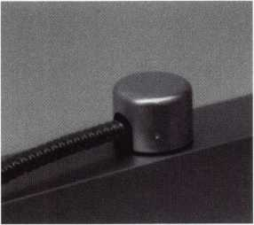

Standard 18”  
length. Can be  
ordered in cus-  
tom lengths

Plastic base stops  
shorts and pro-  
tects wires

Screwless base and cap means you drill two 1/2 inch diameter holes, pop the base into the hole, wire your system and snap on your covers. Simple as 1, 2, 3.

HERE’S THE BEST PART WE ARE GIVING AWAY A

FREE SAMPLE TO THE FIRST **10O** CALLERS WHO MEN-  
TION THIS ADD. **A $14.40** WHOLESALE PRICE VALUE.

CALL TODAY, IT’S FREE!!

1-800-500-1449

Marray *enterprises, inc.*

At **Marray,** we’re not just modifiers, we’re Master Hardware Modifiers™  
**1128 Walsh Ave.,** Santa **Clara, CA 95050. [www.marray.com](http://www.marray.com)**

***May 2001***

Keynotes

39

■ EMPLOYMENT

Experienced Locksmith Wanted

Live, work, and enjoy Florida’s east coast  
in beautiful Brevard, Co. Must be  
able to run after hour calls. Top salary and

or commission. Call

**1-888-752-7233**

Experienced Security Technici

Needed

Growing, established commeri

company with annual sales e^lSding $1  
million seeking experien**cedib**curitv tech-  
nician. Stocked van profiled with inven-  
tory, key machines. gggj? tools. Applicants  
must have knowledge of commercial lock-  
smithing, including extensive master key  
systems (Medeco, Best| Schlage, Sargent,  
etc.). Architectural hard'S^^ installations^  
including locks, hinges, ilisers, exit  
devices, continuous hinges ahfj|^hollow  
metal door replacements. No autbi||jive,

no lockouts, no 24-hr. service. Week<

free.

Awesome opportunity for self-motivated,  
hardworking individuals. Salary commen-  
surate with experience. Paid holidays,  
vacation, medical and dental. Retirement  
plan.

Contact:

Redford Lock Company, Inc.

26515 Grand River Ave.

Redford, Ml 48240 Rhone 313/535-0400 Fax 3131535-0559 e-mail [redfordlock@aol.com](mailto:redfordlock@aol.com)

Experienced Technician Needed

Mid-sized company in sunny California (by the beach) seeking a person with a pos­itive attitude and a friendly smile. We offer paid vacations, paid holidays, med­ical and dental insurance, a SEP-IRA pro­gram, company provided vehicle, tools (except hand tools). We cater mainly to the commercial customer with very little automotive. On call is NOT mandatory. Access Control and safe knowledge is pre­ferred but not required.

Contact: Paul

Phone: 831/423%

fax: 831/423**-J**

yahoo.com

Wanted

shop in the Palm Springs area

California is looking for an experienced

locksmith for field work. Must be profi-  
cient in master keying, safety deposit  
boxes and working knowledge bf safes.  
Salary plus commission. Health insurance  
benefits and 401(k) plan.

Please fax resume to: 760/779-1811 or call  
760/346-5214.

Maintenance Worker III /  
Locksmith, Physical Plant

Under broad supervision, the incumbent is  
responsible for performing maintenance  
improvements, installations and repairs for  
the bu|ldings at the Lowell Campus.  
Primary emphasis will be on locksmith  
duties, door hardware and controlled  
access, as well as supporting the depart-  
ment with interior $ignage and other

Duilding trades. The position requires a

lid Colorado driver's license, license and

£le locksmith credentials and four

years bl||irogressive experience in lock and  
controll**iillicc**ess trade. Also, a GED **oil**High School rd||loma needed.

Regis University^^pFers an excellent bene-  
fits package for '^1-time employees

including 100% tu!t$^ for employee,

spouse and dependents.!

E-mail resumes to resumes@regts!§^ or fax to

303-964-5498

Experienced Locksmiths Wante

Do you love the trade of Locksmithiri

Are you hard working and self motivaed?  
If you are, we are the company for you. A  
growing locksmith company in California  
are looking for tech that work with auto-  
motive, commerical and resdential.  
Looking for tech that has a min. of 2 yrs.  
of exp. We offer full benefit package,paid  
vacations and bounus pay biweekly.  
Trucks and tools are provided and after a  
year of service stock options are avaliable.  
Clean driving record and Bondable is a

must. High salary is payed to top techni-  
cians, average 5 OK to 7 OK. Take pride in  
where you work and come aboard on a  
winning team ^

Locksmith Central  
15934 Hesperian Bird.

Suite 264 **l|||"**

San Lorenzo, Ca 94580 **,**

Voice: 1.888.81.LOCKS  
Fax:(510)317.6860 **^**

<mailto:Lcentral@msn.com>

Wanted:Experienced Technicians

Lock into your future now! If you are an  
experienced, intelligent technician, and  
desire a secure future, come join our team.  
We are a full servie commercial/ residen-  
tial security service (locks, keys, safes,  
cctv, access control, door related hard-  
ware). We offer: large sign on bonus, top  
wages, company vehicle, 40IK, paid vaca-  
tion, paid holidays, health benefits, new  
uniforms, cross-training, and JOB SATIS-  
FACTION. We are looking for the best  
techs who ae ready to be treated and com-  
pensated as professionals. Contact:

Bass Security Services, Inc.

(216) 755-1200 Ext:128

(216) 755-1220 fax

e-mail/ [rmesnick@bass-security.com](mailto:rmesnick@bass-security.com)

Experienced Service  
Technicians Needed

Due to continued growth, we are looking  
for locksmiths, door operator technicians  
and low voltage technicians. Our company  
has been in business since 1880 and is  
located in the beautiful Pacific Northwest.  
Argens Inc. is a multidimensional compa-  
ny. We target commercial and industrial  
accounts. Our company specializes in gen-  
eral locksmithing, electronic security  
(card access & CCTV) and door servicing.  
We are an employee driven company with  
excellent pay, benefits, sales incentives,  
and can offer advancement as our growth  
continues. Send resume to:

Steve Templeton  
Argens Incorporateds84 S. Main Street

Seattle, WA 98104  
(206) 623-2662

***Keynotes***

***May 2001***

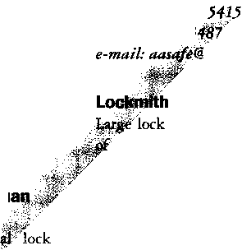

(206) 6^5056 fax

[WWW.C](http://WWW.C)

Servic

Locksn

fast pa

pay. pc

**benefits!**

Mr. Sch

Loss Pr

22865 **,**

Yorba **j**

(7W 2§

■ W/

For Sail

3 **curtilj!**

degree <

120 ca

$2500. |

$550.

& Keys - ]

**PO Box "**

or 1-30%

or 1-386

Two1

Used

system!

units

For **j**site.

ms.com

technician Wanted

service technician needed at

growing firm. Looking for great

ive work environment and full

ckage? Fax resume to:

|dt

\ntion Systems Inc.

\i Ranch Pkwy #B

**|**da, CA 92887

\0092 fax

ED TO BUY/SELL

jipper #15 guns, 1 setup for 47

Is, 1 special case, holds 39 cams,

^es, have 46 cams, 75 carriages

jso have Reed Code Book #1-14,

se contact me at Masons Locks

T1270, Key Largo, FL, 33037

}51-0195  
122-4004

Radio System For Sale

! MHz trunked two way

jth base unit and 36 hand ?

chargers, batteries, and Ays.

Information check out.qnVbb-

**$4000.Cl||or Best offer** LJberP^mck and Safe ***(702) ml-5397*** wwwJimttylock.com

BUSINESSES FOR SALE

Established Locksmith Business

Established locksmith, bicycle repair an<| UPS shipping center in Greenville,

Two or more of everything, vans, machines, duplicators, computers^fcc. 1999 gross $225,000. Priced ‘tdfljy at $75,000. For more informati^^»itact Jerry at (662) 335-9070.

Locksmith and Secui

for Sale

Established 18-year ol<

nice business and r<

Wisconsin. Busin

asking price: $5

jsmess

ness in a very

rarea of western

d teal property

usiness is located

on main level \y^^pvo bedroom apts. On  
second levelJ|H&rtment income over  
$10K per v**e^^B**e current owner will stay  
with the **WKKriorW^4$o** one year to train  
buyer an**djlB**p expand the business.

Call Hmti'Baker at 800/966-2913.

Business For Sale

stablished locksmith and safe com-

in sunny Santa Cruz, California,

ny commercial accounts. Business has

>een in the same location for 41 years.

Two+ years left on lease. Two fully  
equipped mobile units. Must sell due to  
health.

For more information, call 831/438-  
2050. Serious inquiries only, please.

Business for Sale

Successful locksmith business in northern  
California. Two offices. One in Eureka, the  
other in McKinleyville. Largest volume in  
the area. Time to retire. Gross volume last  
year was almost $300K. Includes latest  
equipment, all fixtures, all tools and three  
vehicles. $199,000.

Call Bill Davidson, 707/441-1800.

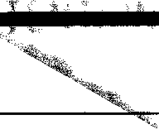

provided free of charge toALOA member^, and for a fee of $.60 per word, $li |fiinimum for non-mem­bers. Classified ads fiay be used to advertise used merchandise and overstocked items for sale, “wantedto buy” items, business oppor­tunities, employment opportunities/posi- tions wanted ana the like. Members or non­members wishing to advertise services or new merchandise for sale may purchase a “Commercial Classified Ad,” for a fee of $1.30 per word, with a minimum of $40. Each ad will run for two issues. For blind boxes there is a $5 charge to members and non-members. All ads must be submitted in writing to the ALOA office by the fifteenth of the month, two months prior to issue date. Send to Keynotes Classifieds, 3003 Live Oak St., Dallas TX 75204-6186. ALOA **reserves** the right to refuse any classified advertise­ment that it deems inappropriate according to the stated purpose of the classified adver­tising section.

Live Ini

Located

equippe

tion. $50,1

to retie

872-4

radise, California. Well

and van. Turn key opera-

takes it all. Owner wishes

>r more information call: (530)

***May 2001***

***Keynotes*** |4l



**MANUFACTURERS**

•A & B Safe Corp.

(800) 253-1267 FAX (856) 863-1208

•Abloy Door Security

(514) 335-9500 FAX (514) 335-0430

•Abus Lock Company

(800) 352-2287 FAX (612) 509-9939

•Adams Rite Manufacturing Co.

(909) 632-2300 FAX (562) 699-5094

•Adesco Safe Manufacturing Co.

web: [www.adesco.com](http://www.adesco.com) (800) 821-6803 FAX (562) 408-6427

•Adrian Steel Company

web: [www.adriansteel.com](http://www.adriansteel.com) (800) 677-2726 FAX (517) 265-5834

•Alarm Lock Systems, Inc.

(800) ALA-LOCK (516) 789-3383

•American Lock Co.

(708) 534-2000 FAX (708) 534-0531

•American Security Products (AMSEC)

(800) 423-1881 FAX (909)685-9685

•Baldwin Hardware Corp.

(610) 736-4012 FAX (610) 796-4493

•Buddy Products

1 (800) 886-8688 FAX (312) 733-8536

• BWD Automotive

9(334) 874-9001 FAX (334) 874-6011

•Curtis Industries

1(800) 555-5397

•DSC Group of Companies

(905) 760-3000 ext. 2200 FAX (905) 760-3040

•Grobet File Co. of America

(800) 962-7242 FAX (800) 243-2432

•HPC, Inc.

(847) 671-6280 FAX (847) 671-6343

* llco Unican

(252) 446-3321 FAX (252) 446-4702

•In Out Systems, Inc.

(450) 444-5949 FAX (450) 444-4856

* Intellikey

(800) 226-0703 FAX (407) 724-0811

•Jet Hardware Mfg. Co

(718) 257-9600 FAX (718) 257-0973

•KABA High Security Locks

(860) 621-3601 FAX (860) 621-9727

•KEY-BAK; Div. of W. Coast Chain Mfg.

(909) 923-7800 FAX (909) 923-0024

* Knaack Manufacturing Co.

(800) 456-7865 FAX (815) 459-9097

•LAB Security

(800) 243-8242 FAX (203) 583-7838

* LCN Closers (Division of Ingersol)

(815) 875-3311 FAX (815) 875-3222

•La Gard, Inc.

(310) 325-5670 FAX (310)325-5615

•Lucky Line Products

(619) 549-6699 FAX (619) 549-0949

•M.A.G. Engineering & Mfg. Inc.

(714) 891-5100 FAX (714) 892-6845

•MARKS USA

(516) 225-5400 FAX (516) 225-6136

•MARRAY ENTERPRISES

•Door Controls International (408) 970-0213; FAX (408) 970-8767

(800) 742-3634

FAX (800) 742-0410 -Master Lock Company

(414) 444-2800

•ESP Lock Products, Inc. FAX (414) 449-3114

(978) 537-6121 FAX (978) 534-9109

•Medeco Security Locks

1. 380-5000 FAX (540) 380-5010

•Meilink Safe Company

(800) 634-5465 FAX (800) 896-6606

•One Lock, One Key Inc.

(817) 860-1011 FAX (817) 275-6839

•ROFU International Corp.

(800) 255-7638 FAX (253) 922-1728

•STRATTEC Security Corp.

(414) 247-3333 FAX (414) 247-3329

•Sargent & Greenleaf, Inc.

(606) 885-9411 FAX (606) 887-2057

•Schlage Lock Co.

(800) 847-1864 FAX (800) 452-0663

•Schwab Corporation

(765) 447-9470 FAX (765) 447-8278

•Securitron Magnalock Corp.

5(800) 624-5625 FAX (702) 355-5636

•Security Door Controls

(805) 494-0622 FAX (800) 959-4732

•Security Solutions

(405) 376-1600 FAX (405) 376-6870

•Sentry Group

(716) 381-4900 FAX (716) 381-8559

•Sully Tools Inc.

(703) 689-3416 FAX (703) 787-0869

•Taymor Industries, Inc.

(800) 388-9887 FAX (800) 288-8133

•Trine Products Corporation

(718) 829-4796 FAX (718) 792-9127

•Videx, Inc.

1. 758-0521 FAX (541) 752-5285

•Visonic, Inc.

(800) 223-0020 FAX (860) 242-8094

Keynotes

***May 2001***

For more complete information visit our Web site at aloa.org

•W-Lok Corporation

(616) 355-4015 FAX (616) 355-4295

•Yale Security Inc.

(800) 438-1951 FAX (800) 338-0965

**DISTRIBUTORS**

•Accredited Lock Supply Co.

(800) 652-2835 FAX (201) 865-5031

•Ace Lock & Security Supply Co.

(800) ACE-LOCK (800) ACE-FAX4

•ADI

(516) 692-1000 FAX (516) 692-3457

•Akron Hardware Consultants, Inc.

(800) 321-9602 FAX (800) 328-6070

•American Security Distribution

(714) 996-0791 FAX (714) 579-3508

•Andrews Wholesale Lock Supply

(717) 272-7422 FAX (717) 274-8679

•Boyle & Chase Inc.

(800) 325-2530 FAX (800) 205-3500

•Clark Security Products, Inc.

(800) 854-2088 FAX (619) 974-5284

•Cook's Building Specialties

(505) 883-5701 FAX (505) 883-5704

•DiMark International

3(800) 235-2435 FAX (805) 928-8034

• Dire's Lock & Key Co.

(303) 294-0176 FAX (303) 294-0198

•Direct Security Supply, Inc.

(800) 252-5757 FAX (800) 452-8600

•Doyle Security Products

(800) 333-6953 FAX (612) 521-0166

•Dugmore & Duncan Inc.

(888) 384-6673 FAX (888) 329-3846

•E. L. Reinhardt Co., Inc.

(800) 328-1311 FAX (612) 481-0166

•Foley-Belsaw Company

(800) 821-3452 FAX (816) 483-5010

•Fried Brothers, Inc.

(800) 523-2924 FAX (800) 541-3489

•HS&S Wholesale Distributors

1(800) 521-2202 FAX (313) 342-7580

•Hans Johnsen Company

(214) 879-1550 FAX (214) 879-1530

•Howard Keys

(704) 598-2291 FAX (704) 598-9110

•IDN, Inc.

(817) 421-5470 FAX (817) 421-5468

* Intermountain Lock & Supply Co

(800) 453-5386 FAX (801) 485-7205

•Jo-Van Distributors Inc.

(416) 752-7249 FAX (416) 752-3845

* Lockmasters, Inc.

(800) 654-0637 FAX (859) 885-7093

•Locks Company

(800) 288-0801 FAX (305) 949-3619

•The Locksmith Store Inc.

(847) 364-5111 FAX (847) 364-5125

•M. Zion Company

(212) 349-8677 FAX (212) 964-0495

•McDonald-DASH Locksmith Supply

(800) 238-7541 FAX (901) 366-0005

•McManus Locksmith Supply, Inc.

(702) 333-9112 FAX (704) 332-8664

•MARRAY ENTERPRISES

(408) 970-0213 FAX (408) 970-8767

•Securite.com

(800) 241-3930 FAX (619) 974-5269

* Omaha Wholesale Hardware

(800) 238-4566

•Sentry Security Fasteners

(309) 693-2800 FAX (309) 693-2872

•Southern Lock and Supply Co.

(800) 237-2875 FAX: (800) 447-2299

* Stone & Berg Wholesale

(800) 225-7405 FAX (800) 535-5625

•Strauss Safe & Lock Company

(515) 288-9571 FAX: (515)288-9752

•Tanner Bolt & Nut Corporation

(718) 434-4502 FAX (718) 434-3215

•Taylor Securtiy & Lock Co.

(301)948-7670 FAX (301) 948-1029

•Timemaster, Inc.

(785) 232-8705 FAX (800) 798-8463

•Top Notch Distributors, Inc.

(800) 722-4210 FAX (800) 248-3620

•U.S. Lock Corporation

(800) 925-5000 FAX (800) 338-5625

•Webster Safe & Lock Company, Inc.

(901)332-2911 FAX (901) 332-2878

**SERVICE**

•Alarm Monitoring Service, Inc.

(504) 454-2163 (504) 456-8737

•Allstate Insurance Company

(847) 402-8196 FAX (847) 326-7509

•Diamond Software

(770) 227-7650 FAX (770) 227-1699

***May 2001***

Keynotes



About the Authors

Walter E. Webb

Advertiser Pages

*is a locksmith with BANK-LOCK SERVICES, Inc. of Alexandria, Virginia.*

*Clifford D."C.D. "Lipscomb, CML,CPS*

*has been working in the physical security industry since 1974 as an  
institutional locksmith and currently as owner of a full service lock-  
smith business in Corsicana, Texas. An ALOA member since 1990,  
C.D. is an ALOA certified instructor and has taught for many lock-  
smith associations including the Texas Locksmiths Association and the  
Greater Dallas Locksmiths Association.. He also has held various  
offices in GDLA and TLA.*

*Sal Dulcamaro,* CML*,*

*has been in the locksmith business for over 26 years.  
He is the president of All Pro Security, Inc. in  
Michigan and has been an ALOA member for 19  
years. A past president of the Locksmith Security  
Association of Michigan. Sal currently serves as*

*editor of the association newsletter. He was named “Keynotes Author  
of the Year” for 1996 and 1997. He is also a contributing edito  
for Keynotes.*

*Find Sal on the internet at: <http://home.earthlink.net/~lockwriter>.*

*Boh Arthur*

*is an ALOA certified instructor who taught at the ALOA convention and at regional conventions in the United States. He owns and oper­ates Arthur Lock & Key in Phoenix, AZ.*

*Charles Stephenson, CPS*

*is an ALOA certified instructor who has taught at the ALOA con­ventions as well as regional conventions in the United States and Canada. Charles is the current Product Manager for the Safe Lock Division of llco Unican and has written many articles for SAVTA and other trade magazines.*

ALOA 2001 IFC

ILCO 1

STAM Insight 5

Intra Lock 7

Turn 10 9

A & B 9

NMLA 10

ABUS 11

HPC 37

MasterLink 39

Marray 39

Fundamentals of Master Keying IBC

Hickok BC

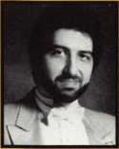

441

Keynotes

May 2001

Get the best master keying textbook

around, written by one of the most

well- known locksmith instructors

in the profession. Just $44.00

(including shipping and handling!

Fundamentals of Master Keying

covers system structure and record

keeping; basic mechanical and

arithmetic concepts; and how to

write a system

To order, write or FAX:

Associated Locksmiths of America, Inc.; 3003 Live

Oak Street Dallas TX 75204 FAX (214) 827-1810

Credit card orders: Phone (214) 827-1701

*An Introduction to Split Pin Master Keying*

**Jerome V. Andrews, CML**

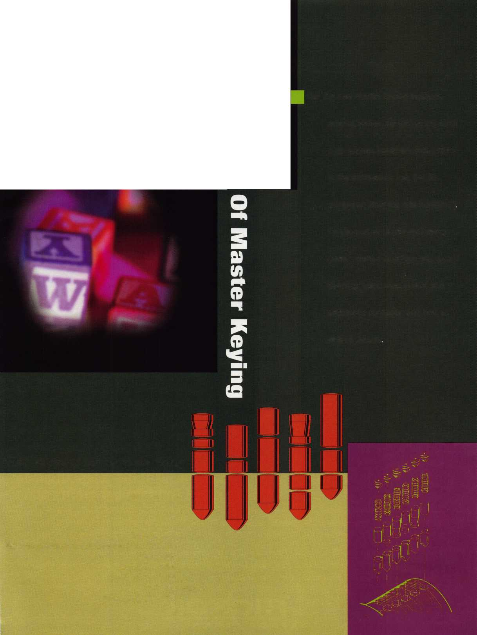

Jump ahead of the competition at warp speed and see your profits soar.

**Hickok’s New Generation STAR transports you with the factory tool for programming keys to  
Ford-Lincoln-Mercury and Mazda vehicles with passive anti theft systems (PATS).**

**-ff Program vehicle keys through Model Year 2001 with Hickok’s NGS Model 800-8LA-$1995 ^ Update your existing software-the 2001 Complete New Model Ford Software Update Model 80LA-$895**

**800/342-5080**

**HICKOK**

INCORPORATED

**[www.hickok-inc.coi](http://www.hickok-inc.coi)**

